

**Activity 7.0 | Orientation to GEAR UP Kentucky**

**Your name (first name, last name): _____________________________________________________**

**OVERVIEW:** Through this activity, you will understand what GEAR UP Kentucky (GUK) is and how it works in your school, all the ways in which participating in GUK will help you, and what opportunities you’ll be able to participate in through GEAR UP Kentucky.

**WHAT YOU NEED TO DO THIS ACTIVITY:**

* Pen/pencil
* *All About GUK* information sheets
* *Dream Big* activity sheet

**WHEN AND HOW TO SUBMIT THIS ACTIVITY:**

* This activity is **DUE by Month XX, 202X.**
* You may submit this activity through your class’ Google Classroom.

**If you need help with this activity, contact your College & Career Coach!**

Name:

Phone number and/or email address:

**Let’s GEAR UP and GO!**

**It’s time to dream …**

It’s time for you to dream a little – well not just a little – I want you to dream BIG. What if I said to you, money isn’t a problem and failure isn’t an option, what would your dream career be?

Now, ask yourself, “What do I need to do to make this happen? What are the steps? What do I need to know?” What questions do you have about that career – or maybe the top two or three careers in which you’re interested?

Well, guess what? GEAR UP Kentucky (GUK) is here to help! We can help you with this – and so much more!

**Instructions:**

Read the *All About GUK information* sheets then complete the *Dream Big* activity sheet.

**AH-HA Moment:** The way you talk to yourself matters and impacts your ability to make your dreams come true. Start talking to yourself the way you’d talk to your best friend – with kindness and encouragement. Just like Henry Ford (founder of Ford Motor Company) said, “Whether you think you can or you or you can’t, you’re right.” It’s time to start thinking you can!

***All About GUK***



Do you know what GEAR UP is or ever heard of the GEAR UP program? Or what GEAR UP stands for?

GEAR UP stands for **G**aining **E**arly **A**wareness and **R**eadiness for **U**ndergraduate **P**rograms.



Our vision is, “Every student prepared for postsecondary success.” Plain and simple, GEAR UP is here to help make sure that every student in this Club is prepared for postsecondary success when they graduate high school. When we talk about postsecondary success, we’re talking about education you pursue after graduating high school - from short-term certifications and credentials to two-year and four-year college degrees – and beyond.

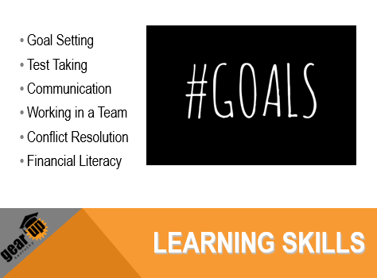

Through GEAR UP, you will learn new skills that are necessary for preparing you for postsecondary success – things that you might not learn in your regular classes, like setting personal and educational goals and having good study skills. You’ll also learn things that will help you for the rest of your life, like working in a team, resolving conflict, communicating effectively with others and some basic things about managing money.



There are lots of other things GEAR UP can help you do, like:

* Set goals for the future
* Do better in school
* Explore careers and postsecondary opportunities
* Visit a college campus (even virtual tours)
* Understand how to apply and pay for college
* Graduate high school ready for postsecondary education/career

Through GEAR UP, you will have all kinds of opportunities – including participating in the **Student Ambassadors** program. By participating in the GEAR UP Student Ambassadors program, you will be given opportunities to represent your peers, engage in FUN activities, and learn a ton of new skills! If this sounds like something you might be interested in, let me know!



Want to keep up with what’s going on with GEAR UP Kentucky? There are four ways you can connect with us online:

* Website
* Facebook
* Twitter
* Instagram

We’d love to see what you and your family are doing to GEAR UP for success! If you take pics related to GEAR UP Kentucky, please be sure to tag us!

That’s enough about us – now I want to know about you! Please complete the *Dream Big* activity sheet – which is all about you and your big dreams! I look forward to getting to know you better!

***Dream Big* Activity Sheet**

*Instructions: Answer the questions below.*

1. **What do you want your life to look like when you’re an adult?** (What career? What kind of home? What kind of car? Do you want to get married? Have kids? Where do you want to live?)

__________________________________________________________________________________________________

__________________________________________________________________________________________________

__________________________________________________________________________________________________

__________________________________________________________________________________________________

__________________________________________________________________________________________________

__________________________________________________________________________________________________

__________________________________________________________________________________________________

__________________________________________________________________________________________________

__________________________________________________________________________________________________

__________________________________________________________________________________________________

__________________________________________________________________________________________________

__________________________________________________________________________________________________

__________________________________________________________________________________________________

__________________________________________________________________________________________________

__________________________________________________________________________________________________

__________________________________________________________________________________________________

__________________________________________________________________________________________________

__________________________________________________________________________________________________

__________________________________________________________________________________________________

__________________________________________________________________________________________________

__________________________________________________________________________________________________

1. **What things do you need to do between now and then to have that kind of life?** (In particular, what kind of education do you need to get? What actions do you need to take? What kind of mindset do you need to have?)

__________________________________________________________________________________________________

__________________________________________________________________________________________________

__________________________________________________________________________________________________

__________________________________________________________________________________________________

__________________________________________________________________________________________________

__________________________________________________________________________________________________

__________________________________________________________________________________________________

__________________________________________________________________________________________________

__________________________________________________________________________________________________

1. **What questions do you have for me?**

__________________________________________________________________________________________________

__________________________________________________________________________________________________

__________________________________________________________________________________________________

__________________________________________________________________________________________________

1. **What question have I not asked you that you wish I had?** What’s something you want me to know about you?

__________________________________________________________________________________________________

__________________________________________________________________________________________________

__________________________________________________________________________________________________

**Thank you for completing this activity!**

See the top of the front page of this activity for instructions on how to submit it.

**Activity 7.1 | Career & College Clubs Orientation**

**Your name (first name, last name): _____________________________________________________**

**OVERVIEW:** Through this activity, you will be introduced to Career & College Clubs, given an overview of your role as a Mentor of a college-going culture, discuss your reasons for participating, and think about ways you could decorate a space to inspire you to reach your career and college goals.

**WHAT YOU NEED TO DO THIS ACTIVITY:**

* Pen/pencil
* *Career & College Clubs Orientation* activity sheet

**WHEN AND HOW TO SUBMIT THIS ACTIVITY:**

* This activity is **DUE by Month XX, 202X.**
* You may submit this activity through your class’ Google Classroom.

**If you need help with this activity, contact your College & Career Coach!**

Name:

Phone number and/or email address:

**Let’s GEAR UP and GO!**

**What is GEAR UP all about? It’s ALL about YOU!**

During your first GEAR UP activity, you learned about what GEAR UP Kentucky is and how it can help you – like exploring your future opportunities, like college and career. When you participate in GEAR UP Kentucky, you will be participating in what is called ‘College & Career Clubs.’

During that activity, you also learned about some ways that you can flex your leadership muscles through GEAR UP. A great way to participate in a leadership role in GEAR UP is by being a College & Career Clubs **Lead Mentor**.

Every student in GEAR UP is called a **Mentor**. This is because each of you will be asked to be leaders and role models, providing support and guidance to your peers.

Some of you will choose to take on a **Lead Mentor** role by reaching out to your peers during this challenging time. As your Coach, I am here to help with the activities. I will assist and support you in any way I can.

**AH-HA Moment:** Surrounding yourself with positive images and ideas can truly change your outlook and help you begin to look towards your future very differently than you once might have.

**Career & College Clubs Activity Sheet**

*Instructions: Answer the questions below.*

1. **What do you hope to learn in GEAR UP Career & College Clubs? What do you want to know more about related to careers and/or college? Write that here:**

__________________________________________________________________________________________________

__________________________________________________________________________________________________

__________________________________________________________________________________________________

__________________________________________________________________________________________________

__________________________________________________________________________________________________

__________________________________________________________________________________________________

1. **Think about one item that makes you think about careers and/or college.** (It could be a college poster or banner, motivational quotes, images of your ideal workplace or career, etc.) **Write down what this item is here – and why it makes you think about careers and/or college. If you want, draw a picture of the item on the back of this (or on another) sheet of paper. (Please be sure to share with me!)**

__________________________________________________________________________________________________

__________________________________________________________________________________________________

__________________________________________________________________________________________________

*I encourage you to decorate your room or a space in your home with this and other items that inspire you. Consider going to your local library for assistance in getting some of these materials, such as old magazines or pictures that you can photocopy or trace and color, for example.*

**Thank you for completing this activity!**

See the top of the front page of this activity for instructions on how to submit it.



**Activity 7.2 | Musical Introductions**

**Your name (first name, last name): _____________________________________________________**

**OVERVIEW:** Through this activity, you will choose and share your ‘theme song.’ Your theme song will represent who you are, what you like, and your view of the future.

**WHAT YOU NEED TO DO THIS ACTIVITY:**

* Pen/pencil
* Lyrics to a song that you think represents you

**WHEN AND HOW TO SUBMIT THIS ACTIVITY:**

* This activity is **DUE by Month XX, 202X.**
* Please submit this activity by (describe).

**If you need help with this activity, contact your College & Career Coach!**

Name:

Phone number and/or email address:

**Let’s GEAR UP and GO!**

**“My theme song is …”**

We all have favorite songs for different reasons. Lots of songs I like because they express things I haven’t been able to put into words. Other songs I like because they motivate me – they get me moving and inspire me to take action.

I think it’s cool to have a ‘theme song’ – a song that represents your personality, who you are, what you’re like, and your view of the future. This is something you can listen to remind you of who you are and/or who you aspire to be – and that you can share with others to help them understand you better.

My own theme song is (CCC, complete this)

I feel like this song represents me because (CCC, complete this)

**Instructions: Answer the questions/complete activities below.**

1. **Choose an appropriate song (be mindful of lyrics, language, and content) that represents your personality, who you are, what you like, or your view of the future. Write the name of the song here:**

**__________________________________________________________________________________________________**

1. **Why did you choose this song? How does it represent you, your personality, what you like, and/or your view of the future? Explain that here.**

**__________________________________________________________________________________________________**

**__________________________________________________________________________________________________**

**__________________________________________________________________________________________________**

**__________________________________________________________________________________________________**

1. **Please share some or all of the lyrics to your theme song here (or on back of this page):**

**__________________________________________________________________________________________________**

**__________________________________________________________________________________________________**

**__________________________________________________________________________________________________**

**__________________________________________________________________________________________________**

**__________________________________________________________________________________________________**

**__________________________________________________________________________________________________**

**__________________________________________________________________________________________________**

**__________________________________________________________________________________________________**

**__________________________________________________________________________________________________**

**__________________________________________________________________________________________________**

**__________________________________________________________________________________________________**

**AH-HA Moment:** Picking a song that you relate to can help you gain insight into who you really are as a person and what you aspire for your future.

**FUN FACT:** Did you know that, in 2016, Mozart sold more CDs than Beyoncé?

**Thank you for completing this activity!** See the top of the front page of this activity for instructions on how to submit it.



**Activity 7.3 | How to Be a Lead Mentor**

**Your name (first name, last name): _____________________________________________________**

**OVERVIEW:** Through this activity, we will take a look at what it means to be a Mentor with Gear UP. We will review Lead Mentor guidelines as well as take another look at the C&C pledge.

**WHAT YOU NEED TO DO THIS ACTIVITY:**

* Pen/pencil
* Refer to the *Lead Mentor Guidelines* handout
* Copy of *Dos and Don’ts as a Leader*
* Copy of the *College & Career Clubs Pledge*
* *What Does It Mean To Me To Be a Leader* worksheet

**WHEN AND HOW TO SUBMIT THIS ACTIVITY:**

* This activity is **DUE by Month XX, 202X.**
* You may submit this activity by (describe).

**If you need help with this activity, contact your College & Career Coach!**

Name

Phone number and/or email address

**Let’s GEAR UP and GO!**

**What does being a Leader mean to you?**

Have you ever thought of yourself as a leader? Have you ever wanted to be a leader? For many people, this is a natural ability, for others it is a learned ability and yet for some it is of no interest at all. The beauty of this … IT’S ALL GOOD! Consider expanding your mind a bit with this activity no matter what category you are currently in.

**Instructions:**

Take some time to read over the handouts and reflect on what being a leader means to you. Sign the *College & Career Clubs Pledge* and fill out the *What Does It Mean to Me to Be a Leader* worksheet.

**AH-HA Moment:** Even though doing a paper packet will not give you the traditional experience of being a Lead Mentor, I encourage you to reach out to your College & Career Coach for ways to still implement being a leader in your community or your own family!

***Lead Mentor Guidelines***

**BEFORE THE MEETING**

* Meet with the other Lead Mentors, if there are any, to review the activity and decide who does what. Everyone should have the opportunity to speak and demonstrate their leadership skills.
* Practice the activity to make sure you fully understand it. If you have any questions, ask the other Lead Mentors or your Coach for help before the meeting. If the activity includes the class researching or exploring a topic, do the research yourself beforehand so you are prepared.
* Have all materials ready to go, including any supplies, copies, and access to technology that might be needed.
* Set up the room. For many activities, arranging the chairs or desks in a circle helps to generate discussion.

**DURING THE MEETING**

**Set the tone.** This is important work so be a good example for other Mentors by taking the activity seriously. You want to be friendly and focused. If some Mentors are not prepared to participate (for example, they won’t stop talking), politely ask them to respect everyone’s time. If they still won’t stop, ask your Coach for assistance.

**Don’t wait for your Coach.** When it is time for class, ask the Mentors to sit down and tell them the meeting is starting.

**Make your presence known.** Stand up straight in front of Mentors. Look everyone in the eye. Most importantly, SPEAK UP so everyone can hear you. Even if you are a little scared, shy, or just having a bad day – project confidence and enthusiasm for the activity.

**Explain what you’re doing.** Before beginning, explain the activity and its purpose, then ask Mentors if they have any questions.

**Help all Mentors to participate in the activity.** If someone hasn’t said anything in a while, ask them for their thoughts. Likewise, if someone is dominating the discussion, ask them to hold back so others can participate.

**Keep track of time.** If you are running long, you may have to adjust the activity.

**Facilitate a discussion.** When the activity is over, lead the Mentors in a discussion using the questions provided. Involve all Mentors in the discussion and thank them for their comments. Be even-handed and don’t just focus on a few individuals.

**HOW TO FACILITATE A CLUB DISCUSSION**

As Lead Mentors, you will very likely be called to facilitate a discussion, which means you are responsible for keeping the discussion on track and productive.

*• continued on next page •*

***Lead Mentor Guidelines, continued***

**Understand your role**

Your role is to help the group explore a topic. You aren’t teaching the material; you’re helping them discuss and learn for themselves. It is important that you stay neutral; don’t try to lead your class discussion to a particular outcome.

**Guide the discussion**

* Ask a question, then allow Mentors to answer and respond to each other. If no Mentors want to answer, you may need to call on one or two to start the discussion by providing their opinion.
* Ask open-ended questions – how, what, why, tell me, describe, etc.
* If the discussion seems to be repeating itself, summarize the point and move to the next question.
* If the discussion is off-track, repeat the original question and ask Mentors to respond to it.
* If a Mentor is dominating the discussion, ask others, by name, for their opinion.
* If a Mentor is not participating, that’s OK. Ask them if they have any thoughts on the question; if they say no, move on.

**Make a visual record**

As Mentors offer their opinions, write down their comments and responses on a whiteboard, flip chart, etc., so everyone can see. Be sure to record everyone’s input, and use their own words as much as possible.

**Encourage a productive discussion**

* Be sure all Mentors have an opportunity to participate.
* When there is disagreement, help Mentors to focus on the facts instead of the people involved. Ensure all sides have their opinions heard. If agreement isn’t possible, acknowledge that, and ask the group if it’s OK to move on.
* Stay positive. Acknowledge in a positive way when a Mentor contributes.

**Summarize the discussion**

Before finishing, summarize the discussion and any specific decisions the class has made.

**Dos & Don’ts as a Leader**

Appropriate vs. Inappropriate Behaviors & Choices

|  |  |  |  |
| --- | --- | --- | --- |
| ***Appropriate:*** |  |  |  |
| Speak clearly | Respond to questions | Help others | Lead by example |
| Improve your writing skills | Listen more than you talk | Set sensible goals | Be optimistic & positive |
| Be prepared | Be on time or early | Know your strengths | Know your limits |
| Persevere | Increase reading | Speak up | Support others |

|  |  |  |  |
| --- | --- | --- | --- |
| ***Inappropriate:*** |  |  |  |
| Speaking fast | Judge others’ responses | Interrupting others | Ignoring people |
| Blaming others | Isolate yourself | Afraid to make mistakes | Take credit For others’ successes |
| Always late | Give up | Pretend or fake it | Name calling |
| Being timid or talking quiet | Be a “know-it-all” | Act out of anger | Bullying |

**Career & College Clubs Pledge**

We, the Mentors at ______________________________________________, want to prepare ourselves and help prepare our peers for success after high school.

In order for Career & College Clubs to be a positive experience for everyone involved, we pledge to:

* **Respect our fellow Mentors and Coach.**
* **Prepare for our role as Lead Mentors.**
* **Participate fully and enthusiastically.**
* **Actively encourage our peers to prepare for college and career success.**
* **Make a positive difference in ourselves, our families, our school, and our community.**
* **Promote our work with Career & College Clubs to our school and community, including responsible use of social media.**
* **Lead by example.**
* **Work hard.**
* **Have fun.**

*Signed: ____________________________________________________*

What Does It Mean To Me To Be a Leader?

Prepared by _______________________________________ (Your Name)

# What is your definition of a leader?

______________________________________________________________________________________________________________________________________________________________________________________________________________________________________________________________________________

# What makes a good leader vs. a poor leader?

______________________________________________________________________________________________________________________________________________________________________________________________________________________________________________________________________________

# Does everyone have the ability to be a leader? Why or why not?

______________________________________________________________________________________________________________________________________________________________________________________________________________________________________________________________________________

# Describe a time when you were a leader. If you have never been a leader, explain how you might try to be a leader in some way.

______________________________________________________________________________________________________________________________________________________________________________________________________________________________________________________________________________

**Thank you for completing this activity!**

See the top of the front page of this activity for instructions on how to submit it.



**Activity 7.4| Degree or No Degree**

**Your name (first name, last name): _____________________________________________________**

**OVERVIEW:** Through this activity, you will learn about the different options available in higher education.

**WHAT YOU NEED TO DO THIS ACTIVITY:**

* Pen/pencil
* *Postsecondary Education Options* handout
* *Degree or No Degree?* handout (w/ chart)
* *Colleges & Universities Partnering with GEAR UP* handout
* *What College, Degree or Career is Right for You?* handout

**WHEN AND HOW TO SUBMIT THIS ACTIVITY:**

* This activity is **DUE by Month XX, 202X.**
* You may submit this activity by (describe).

**If you need help with this activity, contact your College & Career Coach!**

Name

Phone number and/or email address

**Let’s GEAR UP and GO!**

**What does getting a degree mean to you?**

Many people go to a college or university shortly after graduation from high school. This is a wise choice because if you wait too long to go, you may NEVER go. According to the National Center for Education Statistics report, the likelihood of enrolling in a four-year program declined by 30% among those who waited a year after high school graduation. After a 10-year delay, only 8% of those who postponed college enrolled in a bachelor's degree program.

**Instructions:**

Read the *Postsecondary Education Options* handout, look over the *Colleges & Universities Partnering with GEAR UP* handout, and then fill out the *Degree or No Degree* handout with the chart, putting X’s in the boxes you think match the level of education needed for each career listed. After you have completed those, move on to answering the questions on the *What College, Degree or Career is Right for You?* handout.

**AH-HA Moment:** Remember, EVERYONE is different and that is a BEAUTIFUL thing! Embrace learning who you are and what career path will be right for you. Don’t EVER make the mistake of going to college, going to the military, working in a factory or traveling the world, JUST BECAUSE your friend is doing that. GEAR UP will help you explore what is “right” for you and be available every step of the way to help you get there!

***Postsecondary Education Options***

Now that you know the benefits of going to college, let’s talk more about college. How long will it take to earn a college degree? What type of college should you attend? What kind of degree should you earn? These are all questions that you will consider in your future.

Today, you will learn about the different types of colleges and universities and the degrees that they offer.

A wide variety of options are available to students for continuing education beyond high school. They fall into three general categories: Academic Programs, Vocational Programs, and the Military. Let’s take a look at some of the different options available.

**ACADEMIC PROGRAMS**

When most people think of postsecondary education, they think of college. Students who go to college work towards completing a degree. A degree signifies that a student has met the requirements necessary to complete their program of study. Higher education degrees can be earned in one of two different types of institutions:

**Community college** (sometimes referred to as **junior college** or **technical college)** is a two-year postsecondary institution that offers academic programs suited to a particular community. They offer associate degree programs, as well as courses that can be transferred to a four-year college or university. They also frequently offer non-academic courses for personal growth and enrichment.

A **four-year college** or **university** is a postsecondary institution where students work towards earning a bachelor’s degree. You’ll see that some four-year schools are referred to as a ‘college’ and others are ‘universities’. There isn’t too much difference between the two terms. In general, colleges tend to be smaller than universities, and sometimes offer only bachelor’s degrees. Universities tend to be larger and frequently offer master’s and doctoral programs. Large universities may be broken down into smaller colleges — for example, the ‘College of Engineering’ and the ‘College of Education.’

**VOCATIONAL PROGRAMS**

There are two types of vocational programs: **Vocational** or **trade schools** teach skills specific to a particular job or profession. They are not focused on general education. Sample careers include cosmetology, culinary arts, mechanics, and technology-related fields.

Apprenticeships allow individuals to train for technical careers by shadowing a professional. Apprentices earn lower wages while working “on the job” with skilled workers in a specific trade.

It takes approximately four years to complete an apprenticeship. Sample careers include electrician, plumber, and carpenter.

**THE MILITARY PATH**

There are several ways that you can be involved in the military as a postsecondary option. They include:

* Military academies allow students to earn a bachelor’s degree for little or no cost. Graduates must commit to serve in the respective military branch for a period of time after earning their degree.
* Enlisting in the military. You may enlist in the military directly after high school. If you choose to start your career with the military and continue your schooling later, you may be able to take classes and earn money toward future education pursuits during your time of service.

***Postsecondary Education Options, continued***

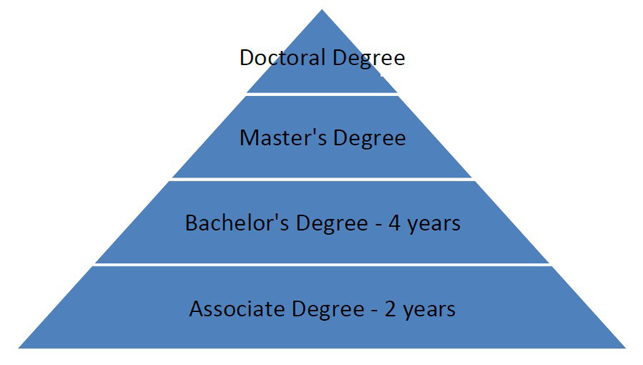**ACADEMIC DEGREES**

Let’s take a moment to discuss the different types of academic degrees that are available. Degrees are divided into different categories depending on the number of years of education you participate in and how in-depth you study a certain subject. The chart to the right details the hierarchy of academic degrees:

An **associate degree** is awarded after approximately two years of full-time study. It usually is equivalent to the first two years of a bachelor’s degree program. You can earn an associate degree at a community college or at some four-year colleges. While some students end their postsecondary education with an associate degree, some use it to transfer to a four-year college.

A **bachelor’s degree** is an undergraduate degree that takes approximately four years of full-time study to complete. It is required for some professions and for licensure in certain fields. It also is required for admission to advanced degree programs, including law and medicine. You may earn a bachelor’s degree at a public or private school. Many students who intend to earn a bachelor’s degree find that beginning their college career with an associate program at a community college is more cost effective. However, it is important to make it clear to your community college advisors that your goal is to continue your education beyond the associate program. They will help you ensure that your transfer to a four-year college or university goes smoothly.

A **master’s degree** is awarded to students who continue their education beyond their bachelor’s degree. It usually takes between one and three years to complete a master’s degree. These degrees are more specialized and usually require doing research. Students in these programs typically focus on a specific topic in detail. Some doctoral programs require that applicants already have a master’s degree in order to be considered for admission.

A **doctoral degree** is the most advanced degree. It usually takes between three and seven years to complete a doctoral degree. A bachelor’s degree and often a master’s degree are required of students who are interested in pursuing these degrees. Doctoral degrees are often referred to as “terminal” degrees — meaning, it is expected that if you have a doctoral degree in a particular subject, you are an expert on that subject. These degrees require quite a bit of research in the chosen field. Medical doctors, dentists, and lawyers all have doctoral degrees. Doctoral programs are also offered in academic fields. Most college professors have doctoral degrees in the subject they teach.

**Colleges & Universities Partnering with**

**GEAR UP Kentucky**

|  |  |  |
| --- | --- | --- |
| C:\Users\SArmst\AppData\Local\Microsoft\Windows\INetCache\Content.MSO\9377E94A.tmp | C:\Users\SArmst\AppData\Local\Microsoft\Windows\INetCache\Content.MSO\1D0ACCC.tmp | C:\Users\SArmst\AppData\Local\Microsoft\Windows\INetCache\Content.MSO\A6EA54A6.tmp |
| C:\Users\SArmst\AppData\Local\Microsoft\Windows\INetCache\Content.MSO\BD2B5F06.tmp | C:\Users\SArmst\AppData\Local\Microsoft\Windows\INetCache\Content.MSO\3B145CEA.tmp | C:\Users\SArmst\AppData\Local\Microsoft\Windows\INetCache\Content.MSO\C11FE654.tmp |
| C:\Users\SArmst\AppData\Local\Microsoft\Windows\INetCache\Content.MSO\5621B7EE.tmp | C:\Users\SArmst\AppData\Local\Microsoft\Windows\INetCache\Content.MSO\FD4BC490.tmp | C:\Users\SArmst\AppData\Local\Microsoft\Windows\INetCache\Content.MSO\82C98530.tmp |

These are the colleges where GEAR UP Kentucky students will be getting support from GEAR UP staff through their first year of postsecondary education.

**Degree or No Degree?**

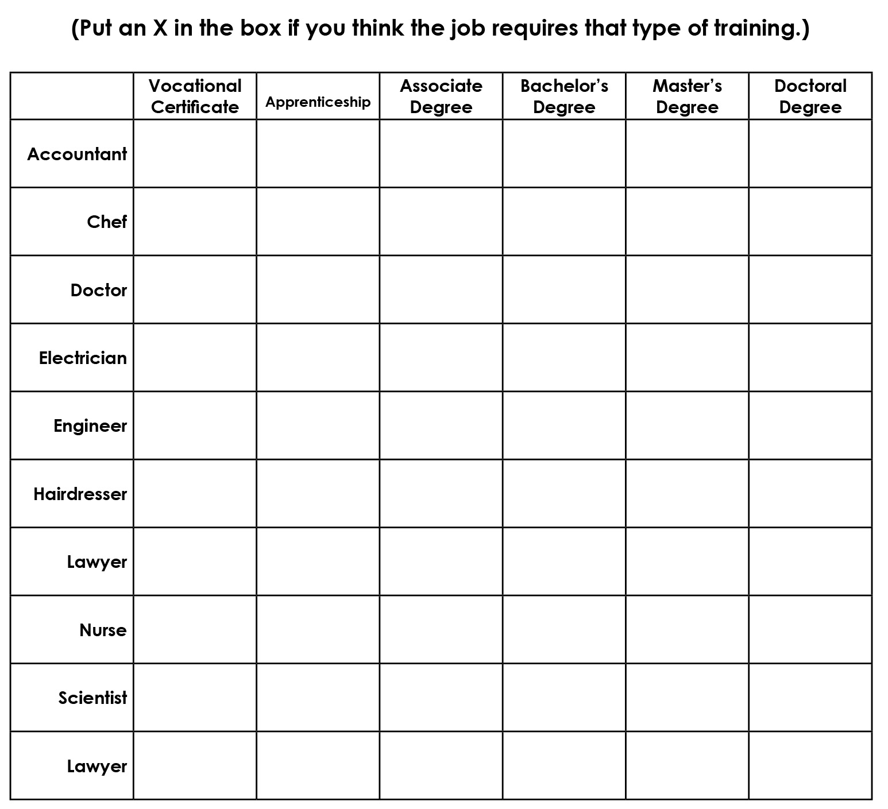

**What College, Degree, or Career is Right for You?**



1. **What colleges and universities are close to your community?** **Which ones are in your state?**

1. **Do you have relatives and/or friends who have attended these colleges or universities?**

**What degrees did they earn?**

**What careers do they have?**

1. **What type of institution (college, university, technical college, community college) might be right for you and your career goals? Why?**

1. **What type of degree do you hope to earn? Why?**

1. **What careers can this degree help you achieve?**

**Thank you for completing this activity!**

See the top of the front page of this activity for instructions on how to submit it.



**Activity 7.5 | Investing in Your Future**

**Your name (first name, last name): _____________________________________________________**

**OVERVIEW:** Through this activity, you will calculate and compare the average cost of a college

degree vs. potential earnings over time to discover how investing in your education pays off.

**WHAT YOU NEED TO DO THIS ACTIVITY:**

* Pen/pencil
* Investing in Your Future handout
* Paycheck It Out handout

**WHEN AND HOW TO SUBMIT THIS ACTIVITY:**

* This activity is **DUE by Month XX, 202X.**
* You may submit this activity by (describe).

**If you need help with this activity, contact your College & Career Coach!**

Name

Phone number and/or email address

**Let’s GEAR UP and GO!**

**What does investing in your future mean to you? What might the pay offs be?**

Making some sacrifices in the present to gain a further education can reap many rewards later. It means investing your time and money to get a certificate, a skill, and/or a degree that might not give you immediate return, but which could give you tremendous value later that could be priceless. Once you earn that degree or certificate, NOBODY can take that away from you!

**Instructions:**

1. Complete the *Investing in Your Future* handout.
2. Complete the *Paycheck It Out* handout.

**AH-HA Moment:** Research from the Federal Reserve bank of New York concludes that the average college graduate earns $30,000 or more a year than an individual with only a high school education.

**Thank you for completing this activity!** See the top of the front page of this activity for instructions on how to submit it.

***Investing In Your Future* Handout**

Even though the cost of college is significant, it pays off in the long run!

We all have wants and needs that require money and having a college degree will help you afford the future life you want to achieve. There are many benefits to pursuing a college education. If you earn a college degree, you have the potential to make more money than a person without a college degree! A college education can also prepare you for a fulfilling, rewarding career!

**College is for YOU!**

Are you worried that there may be financial barriers that can prevent you from going to college? Don’t worry! There are resources that can help you pay for college!

**FINANCIAL RESOURCES**

**Grants**

If you need money to pay for college, both the federal government and state agencies provide eligible students with financial assistance in the form of grants – money that doesn’t have to be repaid … ever. Consider it a gift from the state or federal government.

**Scholarships**

Like grants, scholarships are “free” money that you don’t have to repay. You may be eligible for a scholarship based on grades and test scores, your intended major, a special talent, athletic or leadership ability, family history or heritage, or community service.

**Savings**

It’s never too soon to start saving for education beyond high school…every little bit helps. State programs can help families save for college. The federal work-study program can also help students earn money while they attend college.

**Federal Student Loans**

The federal government offers student loans to help cover the cost of college. A student loan may be the answer if you don’t have enough money to cover all your college expenses. A student loan is often better than using credit cards or taking out a higher-interest personal loan. Unlike a grant or scholarship, a loan must be repaid.

**KHEAA (www.kheaa.com)**

The Kentucky Higher Education Assistance Authority uses Kentucky lottery money to create post-secondary savings accounts for Kentucky students based upon courses taken, grades earned, and test scores achieved.

***Investing In Your Future* Handout, continued**

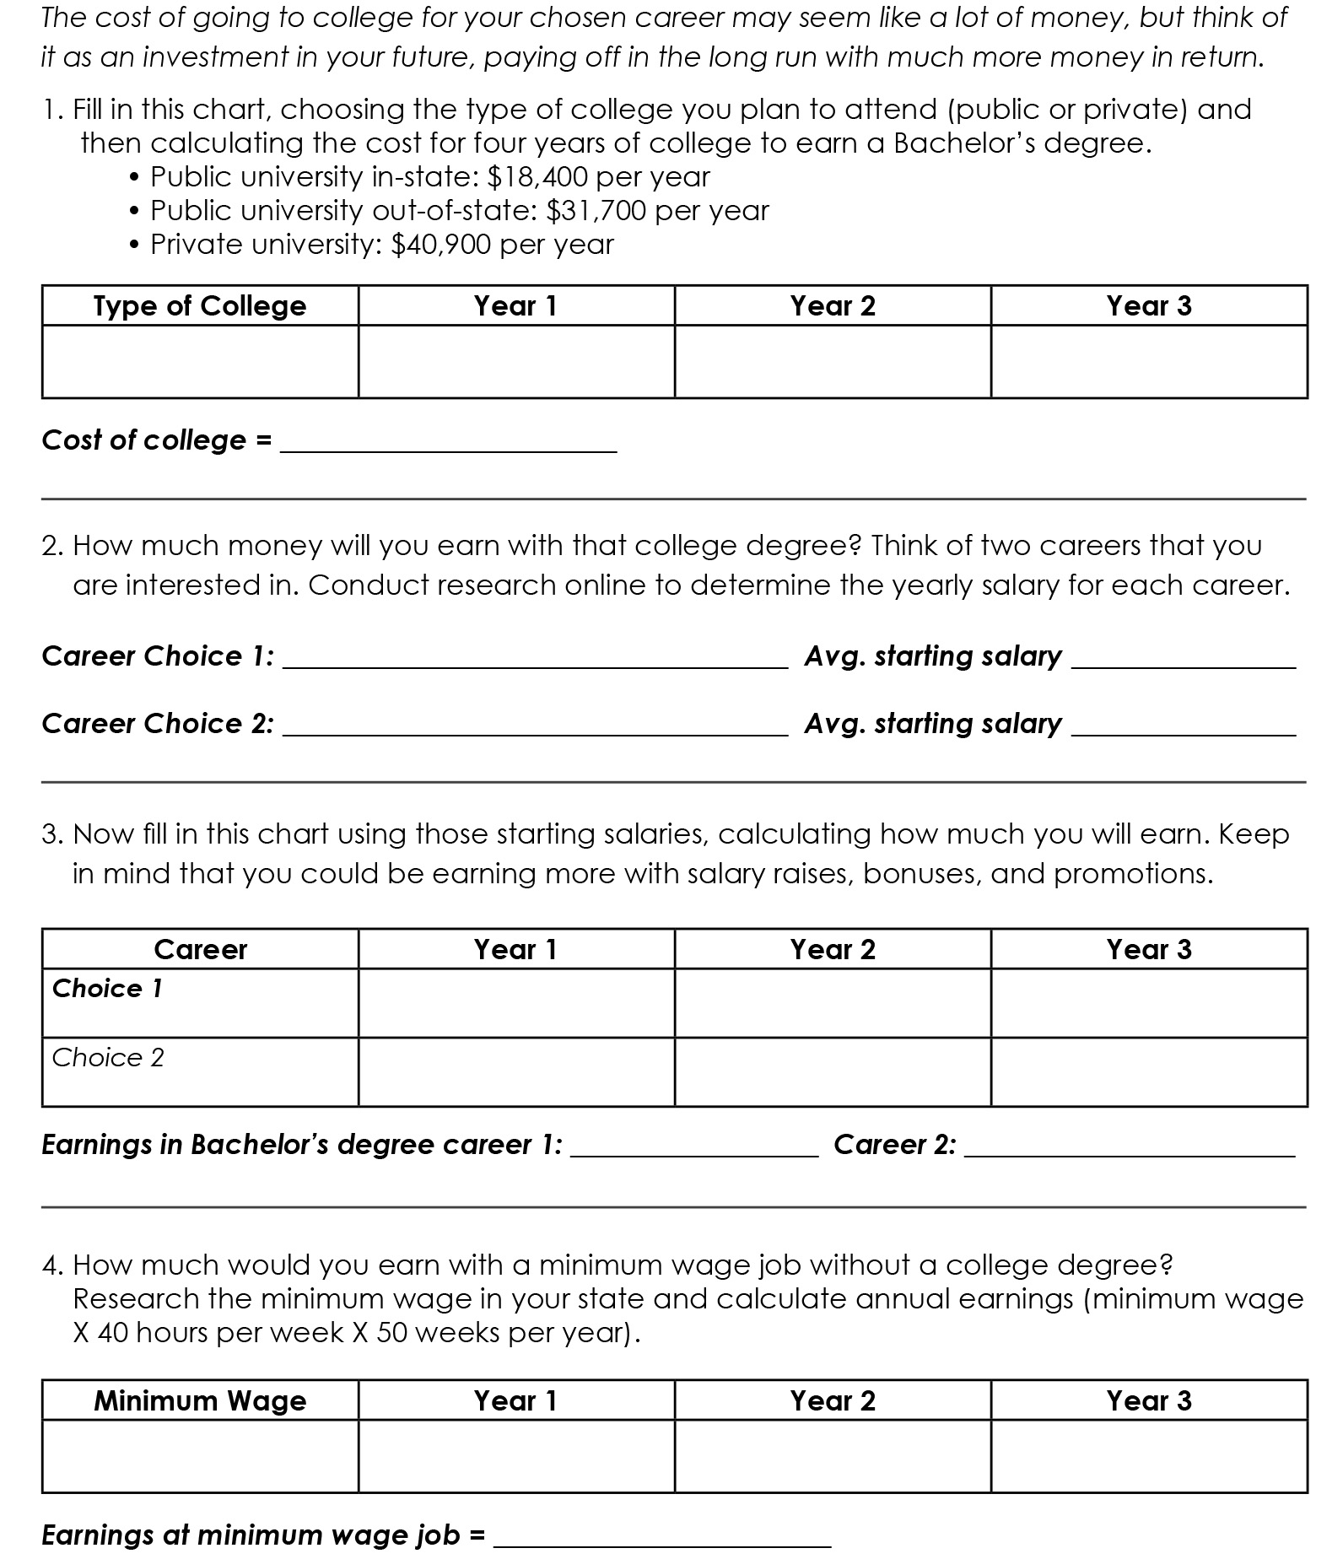

***Paycheck It Out* Handout**

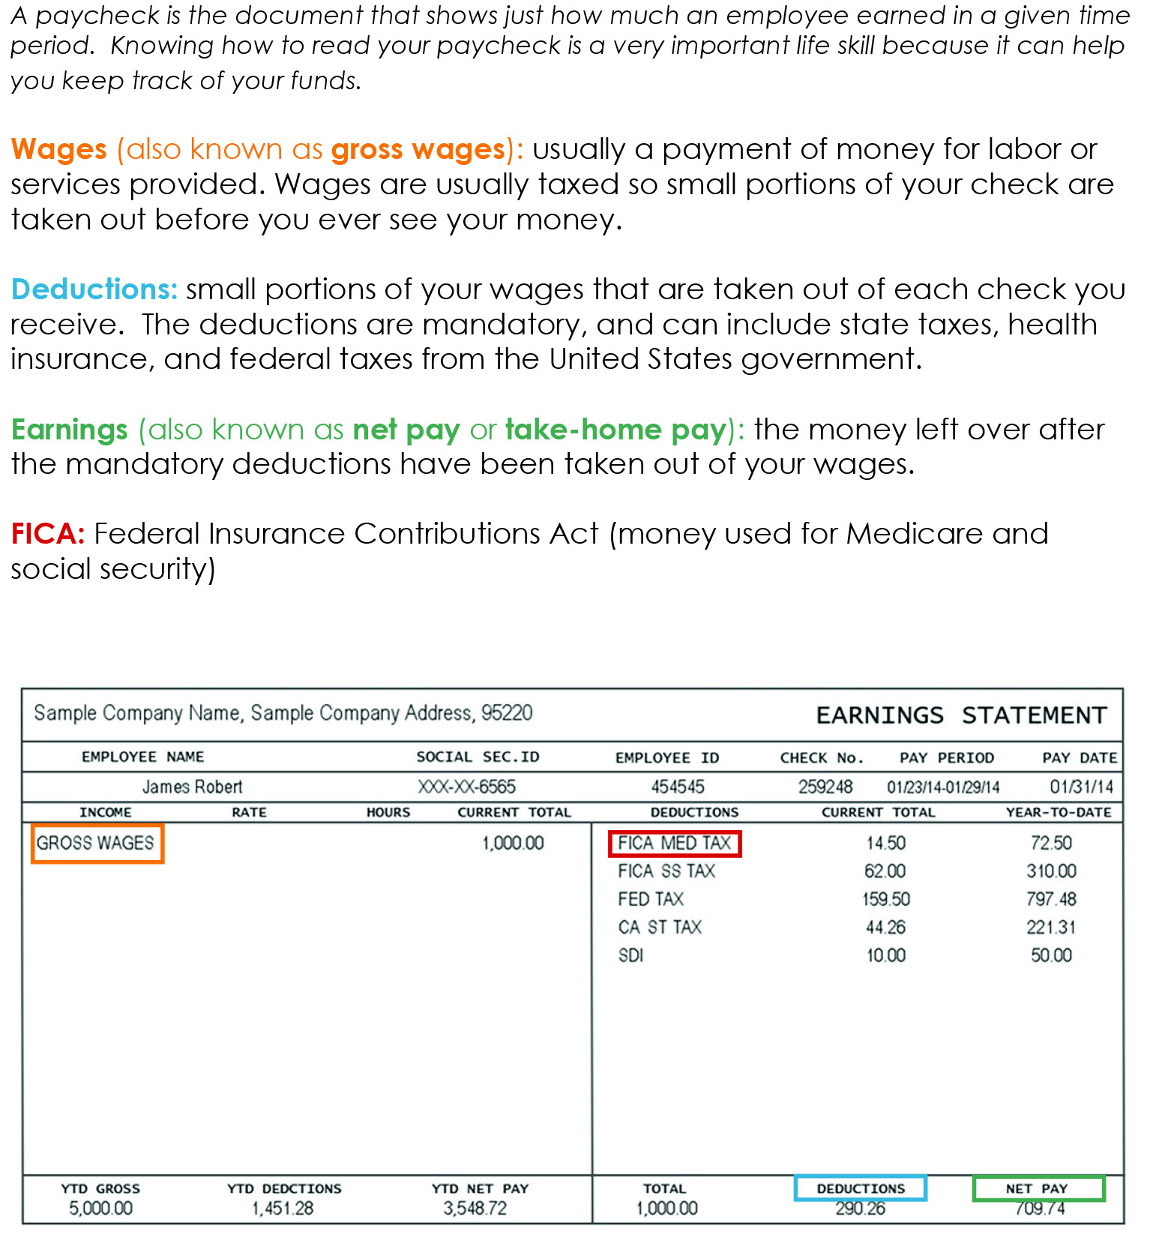

**Activity 8.0 | Orientation to GEAR UP Kentucky**

**Your name (first name, last name): _____________________________________________________**

**OVERVIEW:** Through this activity, you will understand what GEAR UP Kentucky (GUK) is and how it works in your school, all the ways in which participating in GUK will help you, and what opportunities you’ll be able to participate in through GEAR UP Kentucky.

**WHAT YOU NEED TO DO THIS ACTIVITY:**

* Pen/pencil
* *All About GUK* information sheets
* *Dream Big* activity sheet

**WHEN AND HOW TO SUBMIT THIS ACTIVITY:**

* This activity is **DUE by Month XX, 202X.**
* You may submit this activity through your class’ Google Classroom.

**If you need help with this activity, contact your College & Career Coach!**

Name:

Phone number and/or email address:

**Let’s GEAR UP and GO!**

**It’s time to dream …**

It’s time for you to dream a little – well not just a little – I want you to dream BIG. What if I said to you, money isn’t a problem and failure isn’t an option, what would your dream career be?

Now, ask yourself, “What do I need to do to make this happen? What are the steps? What do I need to know?” What questions do you have about that career – or maybe the top two or three careers in which you’re interested?

Well, guess what? GEAR UP Kentucky (GUK) is here to help! We can help you with this – and so much more!

**Instructions:**

Read the *All About GUK information* sheets then complete the *Dream Big* activity sheet.

**AH-HA Moment:** The way you talk to yourself matters and impacts your ability to make your dreams come true. Start talking to yourself the way you’d talk to your best friend – with kindness and encouragement. Just like Henry Ford (founder of Ford Motor Company) said, “Whether you think you can or you or you can’t, you’re right.” It’s time to start thinking you can!

***All About GUK***



Do you know what GEAR UP is or ever heard of the GEAR UP program? Or what GEAR UP stands for?

GEAR UP stands for **G**aining **E**arly **A**wareness and **R**eadiness for **U**ndergraduate **P**rograms.



Our vision is, “Every student prepared for postsecondary success.” Plain and simple, GEAR UP is here to help make sure that every student in this Club is prepared for postsecondary success when they graduate high school. When we talk about postsecondary success, we’re talking about education you pursue after graduating high school - from short-term certifications and credentials to two-year and four-year college degrees – and beyond.



Through GEAR UP, you will learn new skills that are necessary for preparing you for postsecondary success – things that you might not learn in your regular classes, like setting personal and educational goals and having good study skills. You’ll also learn things that will help you for the rest of your life, like working in a team, resolving conflict, communicating effectively with others, and some basic things about managing money.



There are lots of other things GEAR UP can help you do, like:

* Set goals for the future
* Do better in school
* Explore careers and postsecondary opportunities
* Visit a college campus (even virtual tours)
* Understand how to apply and pay for college
* Graduate high school ready for postsecondary education/career

Through GEAR UP, you will have all kinds of opportunities – including participating in the **Student Ambassadors** program. By participating in the GEAR UP Student Ambassadors program, you will be given opportunities to represent your peers, engage in FUN activities, and learn a ton of new skills! If this sounds like something you might be interested in, let me know!



Want to keep up with what’s going on with GEAR UP Kentucky? There are four ways you can connect with us online:

* Website
* Facebook
* Twitter
* Instagram

We’d love to see what you and your family are doing to GEAR UP for success! If you take pics related to GEAR UP Kentucky, please be sure to tag us!

That’s enough about us – now I want to know about you! Please complete the *Dream Big* activity sheet – which is all about you and your big dreams! I look forward to getting to know you better!

***Dream Big* Activity Sheet**

*Instructions: Answer the questions below.*

1. **What do you want your life to look like when you’re an adult?** (What career? What kind of home? What kind of car? Do you want to get married? Have kids? Where do you want to live?)

__________________________________________________________________________________________________

__________________________________________________________________________________________________

__________________________________________________________________________________________________

__________________________________________________________________________________________________

__________________________________________________________________________________________________

__________________________________________________________________________________________________

__________________________________________________________________________________________________

__________________________________________________________________________________________________

__________________________________________________________________________________________________

__________________________________________________________________________________________________

__________________________________________________________________________________________________

__________________________________________________________________________________________________

__________________________________________________________________________________________________

__________________________________________________________________________________________________

__________________________________________________________________________________________________

__________________________________________________________________________________________________

__________________________________________________________________________________________________

__________________________________________________________________________________________________

__________________________________________________________________________________________________

__________________________________________________________________________________________________

__________________________________________________________________________________________________

1. **What things do you need to do between now and then to have that kind of life?** (In particular, what kind of education do you need to get? What actions do you need to take? What kind of mindset do you need to have?)

__________________________________________________________________________________________________

__________________________________________________________________________________________________

__________________________________________________________________________________________________

__________________________________________________________________________________________________

__________________________________________________________________________________________________

__________________________________________________________________________________________________

__________________________________________________________________________________________________

__________________________________________________________________________________________________

__________________________________________________________________________________________________

1. **What questions do you have for me?**

__________________________________________________________________________________________________

__________________________________________________________________________________________________

__________________________________________________________________________________________________

__________________________________________________________________________________________________

1. **What question have I not asked you that you wish I had?** What’s something you want me to know about you?

__________________________________________________________________________________________________

__________________________________________________________________________________________________

__________________________________________________________________________________________________

**Thank you for completing this activity!**

See the top of the front page of this activity for instructions on how to submit it.

**Activity 8.1 | College & Career Clubs Orientation**

**Your name (first name, last name): _____________________________________________________**

**OVERVIEW:** Through this activity, you will be introduced to Career & College Clubs, given an overview of your role as a Mentor of a college-going culture, discuss your reasons for participating, and decide on Career & College Clubs goals and code of conduct.

**WHAT YOU NEED TO DO THIS ACTIVITY:**

* Pen/pencil
* Copy of *The Career & College Club Pledge*

**WHEN AND HOW TO SUBMIT THIS ACTIVITY:**

* This activity is **DUE by Month XX, 202X.**
* You may submit this activity through your class’ Google Classroom.

**If you need help with this activity, contact your College & Career Coach!**

Name:

Phone number and/or email address:

**Let’s GEAR UP and GO!**

**What is GEAR UP all about? It’s ALL about YOU!**

During your first GEAR UP activity, you learned about what GEAR UP Kentucky is and how it can help you – like exploring your future opportunities, like college and career. When you participate in GEAR UP Kentucky, you will be participating in what is called ‘College & Career Clubs.’

During that activity, you also learned about some ways that you can flex your leadership muscles through GEAR UP. A great way to participate in a leadership role in GEAR UP is by being a College & Career Clubs **Lead Mentor**.

Every student in GEAR UP is called a **Mentor**. This is because each of you will be asked to be leaders and role models, providing support and guidance to your peers.

Some of you will choose to take on a **Lead Mentor** role by reaching out to your peers during this challenging time. As your Coach, I am here to help with the activities. I will assist and support you in any way I can.

**Instructions: Answer the questions/complete activities below.**

1. **What do you hope to learn in GEAR UP College & Career Clubs? What do you want to know more about related to careers and/or college? Write that here:**

__________________________________________________________________________________________________

__________________________________________________________________________________________________

__________________________________________________________________________________________________

__________________________________________________________________________________________________

__________________________________________________________________________________________________

1. **Think about one item that makes you think about careers and/or college.** (It could be a college poster or banner, motivational quotes, images of your ideal workplace or career, etc.) **Write down what this item is here – and why it makes you think about careers and/or college. If you want, draw a picture of the item on the back of this (or on another) sheet of paper. (Please be sure to share with me!)**

__________________________________________________________________________________________________

__________________________________________________________________________________________________

__________________________________________________________________________________________________

*I encourage you to decorate your room or a space in your home with this and other items that inspire you. Consider going to your local library for assistance in getting some of these materials, such as old magazines or pictures that you can photocopy or trace and color, for example.*

1. **Read the College & Career Clubs Pledge on the next page. This pledge outlines rules that College & Career Clubs members pledge to follow, such as being respectful and working hard. What is one rule you would like to add to this pledge? Write it here. (It can be serious or silly!)**

__________________________________________________________________________________________________

__________________________________________________________________________________________________

**AH-HA Moment:** Surrounding yourself with positive images and ideas can truly change your outlook and help you begin to look towards your future very differently than you once might have.

**Career & College Clubs Pledge**

We, the Mentors at ______________________________________________, want to prepare ourselves and help prepare our peers for success after high school.

In order for Career & College Clubs to be a positive experience for everyone involved, we pledge to:

* **Respect our fellow Mentors and Coach.**
* **Prepare for our role as Lead Mentors.**
* **Participate fully and enthusiastically.**
* **Actively encourage our peers to prepare for college and career success.**
* **Make a positive difference in ourselves, our families, our school, and our community.**
* **Promote our work with Career & College Clubs to our school and community, including responsible use of social media.**
* **Lead by example.**
* **Work hard.**
* **Have fun.**

*Signed: ____________________________________________________*

**Thank you for completing this activity!**

See the top of the front page of this activity for instructions on how to submit it.



**Activity 8.2 | How to Be a Lead Mentor**

**Your name (first name, last name): _____________________________________________________**

**OVERVIEW:** Through this activity, we will take a look at what it means to be a Mentor with Gear UP. We will review Lead Mentor guidelines as well as take another look at the C&C pledge.

**WHAT YOU NEED TO DO THIS ACTIVITY:**

* Pen/pencil
* Refer to the *Lead Mentor Guidelines* handout
* Copy of *Dos and Don’ts as a Leader*
* Copy of the *College & Career Clubs Pledge*
* *What Does It Mean To Me To Be a Leader* worksheet

**WHEN AND HOW TO SUBMIT THIS ACTIVITY:**

* This activity is **DUE by Month XX, 202X.**
* You may submit this activity by (describe).

**If you need help with this activity, contact your College & Career Coach!**

Name

Phone number and/or email address

**Let’s GEAR UP and GO!**

**What does being a Leader mean to you?**

Have you ever thought of yourself as a leader? Have you ever wanted to be a leader? For many people, this is a natural ability, for others it is a learned ability and yet for some it is of no interest at all. The beauty of this … IT’S ALL GOOD! Consider expanding your mind a bit with this activity no matter what category you are currently in.

**Instructions:**

Take some time to read over the handouts and reflect on what being a leader means to you. Sign the *College & Career Clubs Pledge* and fill out the *What Does It Mean to Me to Be a Leader* worksheet.

**AH-HA Moment:** Even though doing a paper packet will not give you the traditional experience of being a Lead Mentor, I encourage you to reach out to your College & Career Coach for ways to still implement being a leader in your community or your own family!

***Lead Mentor Guidelines***

**BEFORE THE MEETING**

* Meet with the other Lead Mentors, if there are any, to review the activity and decide who does what. Everyone should have the opportunity to speak and demonstrate their leadership skills.
* Practice the activity to make sure you fully understand it. If you have any questions, ask the other Lead Mentors or your Coach for help before the meeting. If the activity includes the class researching or exploring a topic, do the research yourself beforehand so you are prepared.
* Have all materials ready to go, including any supplies, copies, and access to technology that might be needed.
* Set up the room. For many activities, arranging the chairs or desks in a circle helps to generate discussion.

**DURING THE MEETING**

**Set the tone.** This is important work so be a good example for other Mentors by taking the activity seriously. You want to be friendly and focused. If some Mentors are not prepared to participate (for example, they won’t stop talking), politely ask them to respect everyone’s time. If they still won’t stop, ask your Coach for assistance.

**Don’t wait for your Coach.** When it is time for class, ask the Mentors to sit down and tell them the meeting is starting.

**Make your presence known.** Stand up straight in front of Mentors. Look everyone in the eye. Most importantly, SPEAK UP so everyone can hear you. Even if you are a little scared, shy, or just having a bad day – project confidence and enthusiasm for the activity.

**Explain what you’re doing.** Before beginning, explain the activity and its purpose, then ask Mentors if they have any questions.

**Help all Mentors to participate in the activity.** If someone hasn’t said anything in a while, ask them for their thoughts. Likewise, if someone is dominating the discussion, ask them to hold back so others can participate.

**Keep track of time.** If you are running long, you may have to adjust the activity.

**Facilitate a discussion.** When the activity is over, lead the Mentors in a discussion using the questions provided. Involve all Mentors in the discussion and thank them for their comments. Be even-handed and don’t just focus on a few individuals.

**HOW TO FACILITATE A CLUB DISCUSSION**

As Lead Mentors, you will very likely be called to facilitate a discussion, which means you are responsible for keeping the discussion on track and productive

*• continued on next page •*

***Lead Mentor Guidelines, continued***

**Understand your role**

Your role is to help the group explore a topic. You aren’t teaching the material; you’re helping them discuss and learn for themselves. It is important that you stay neutral; don’t try to lead your class discussion to a particular outcome.

**Guide the discussion**

* Ask a question, then allow Mentors to answer and respond to each other. If no Mentors want to answer, you may need to call on one or two to start the discussion by providing their opinion.
* Ask open-ended questions – how, what, why, tell me, describe, etc.
* If the discussion seems to be repeating itself, summarize the point and move to the next question.
* If the discussion is off-track, repeat the original question and ask Mentors to respond to it.
* If a Mentor is dominating the discussion, ask others, by name, for their opinion.
* If a Mentor is not participating, that’s OK. Ask them if they have any thoughts on the question; if they say no, move on.

**Make a visual record**  
As Mentors offer their opinions, write down their comments and responses on a whiteboard, flip chart, etc., so everyone can see. Be sure to record everyone’s input, and use their own words as much as possible.

**Encourage a productive discussion**

* Be sure all Mentors have an opportunity to participate.
* When there is disagreement, help Mentors to focus on the facts instead of the people involved. Ensure all sides have their opinions heard. If agreement isn’t possible, acknowledge that, and ask the group if it’s OK to move on.
* Stay positive. Acknowledge in a positive way when a Mentor contributes.

**Summarize the discussion**  
Before finishing, summarize the discussion and any specific decisions the class has made.

**Dos & Don’ts as a Leader**

Appropriate vs. Inappropriate Behaviors & Choices

|  |  |  |  |
| --- | --- | --- | --- |
| ***Appropriate:*** |  |  |  |
| Speak clearly | Respond to questions | Help others | Lead by example |
| Improve your writing skills | Listen more than you talk | Set sensible goals | Be optimistic & positive |
| Be prepared | Be on time or early | Know your strengths | Know your limits |
| Persevere | Increase reading | Speak up | Support others |

|  |  |  |  |
| --- | --- | --- | --- |
| ***Inappropriate:*** |  |  |  |
| Speaking fast | Judge others’ responses | Interrupting others | Ignoring people |
| Blaming others | Isolate yourself | Afraid to make mistakes | Take credit For others’ successes |
| Always late | Give up | Pretend or fake it | Name calling |
| Being timid or talking quiet | Be a “know-it-all” | Act out of anger | Bullying |

**Career & College Clubs Pledge**

We, the Mentors at ______________________________________________, want to prepare ourselves and help prepare our peers for success after high school.

In order for Career & College Clubs to be a positive experience for everyone involved, we pledge to:

* **Respect our fellow Mentors and Coach.**
* **Prepare for our role as Lead Mentors.**
* **Participate fully and enthusiastically.**
* **Actively encourage our peers to prepare for college and career success.**
* **Make a positive difference in ourselves, our families, our school, and our community.**
* **Promote our work with Career & College Clubs to our school and community, including responsible use of social media.**
* **Lead by example.**
* **Work hard.**
* **Have fun.**

*Signed: ____________________________________________________*

What Does It Mean To Me To Be a Leader?

Prepared by _______________________________________ (Your Name)

# 1. What is your definition of a leader?

______________________________________________________________________________________________________________________________________________________________________________________________________________________________________________________________________________

# 2. What makes a good leader vs. a poor leader?

______________________________________________________________________________________________________________________________________________________________________________________________________________________________________________________________________________

# 3. Does everyone have the ability to be a leader? Why or why not?

______________________________________________________________________________________________________________________________________________________________________________________________________________________________________________________________________________

# 4. Describe a time when you were a leader. If you have never been a leader, explain how you might try to be a leader in some way.

______________________________________________________________________________________________________________________________________________________________________________________________________________________________________________________________________________



**Activity 8.3 | Being a Star Student**

**Your name (first name, last name): _____________________________________________________**

**OVERVIEW:** Through this activity, you will explore & discover the behaviors of successful students and explain the importance of doing well in school.

**WHAT YOU NEED TO DO THIS ACTIVITY:**

* Pen/pencil
* *Sample Student Scenario*
* *Being a Star Student* question sheet

**WHEN AND HOW TO SUBMIT THIS ACTIVITY:**

* This activity is **DUE by Month XX, 202X.**
* You may submit this activity by (describe).

**If you need help with this activity, contact your College & Career Coach!**

Name

Phone number and/or email address

**Let’s GEAR UP and GO!**

**Why strive to be a Star Student?**

Learning about colleges and planning your visit should make you excited about the future and all of the opportunities that are available to you! The goal of the Career & College Clubs program is to help get you ready for college and a successful career. Achieving that goal means doing well in school NOW! The knowledge and skills that you gain from your classes today will prepare you for college classes in the future.

**Instructions:**

In this activity, you will work to identify and understand the qualities of successful students.

1. Read the sample student scenario. Contemplate the qualities, characteristics & behaviors that make Deon a successful student. List these qualities, characteristics and behaviors in the lines provided on the scenario sheet.
2. Answer the questions on the *Being a* *Star Student* question sheet.

**AH-HA Moment:** “By failing to prepare, you are preparing to fail.” ~ Benjamin Franklin

**Thank you for completing this activity!** See the top of the front page of this activity for instructions on how to submit it.

***Sample Student Scenario:* Deon**

It is the end of the year and Deon and his parents are attending the end-of-school awards program. Deon is excited and his parents are beaming with pride as Deon will be receiving a perfect attendance award and a certificate for the A/B Honor Roll. Deon is committed to doing well in school and is proud that his grades in school reflect his hard work.

**Now brainstorm and answer the following question:**

Given Deon’s accomplishments, what characteristics and behaviors helped him achieve success as a star student?

__________________________________________________________________________________________________________________________________________________________________________________________________________________________________________________________________________________________________________________________________________________________________________________________________________________________________________________________________________________________________________________________________________________________________________________________________________________________________________________________________________________________________________________________________________________________________________________________________________________________________________________________________________________________________________________________________________________________________________________________________________________________________________________________________________________________________________________________________________________________________________________________________________________

__________________________________________________________________________________________

__________________________________________________________________________________________

**Being a Star Student Question Sheet**

**How do the following behaviors help star students succeed?**

1. Attending school regularly. ____________________________________________________________________________________
2. Paying attention in class. ____________________________________________________________________________________
3. Asking questions. ____________________________________________________________________________________
4. Participating in class activities and discussion. ____________________________________________________________________________________
5. Studying daily. ____________________________________________________________________________________
6. Completing homework assignments. ____________________________________________________________________________________
7. Submitting assignments and projects on time. ____________________________________________________________________________________
8. Taking notes in class. ____________________________________________________________________________________

What other learning strategies can help you succeed in school? __________________________________________________________________________________________________________________________________________________________________________________________________________________________________________________________________________________________________________________________________________________________________________________________________________________________________________________________________

**Thank you for completing this activity!**

See the top of the front page of this activity for instructions on how to submit it.



**Activity 8.4 | How to Learn Successfully**

**Your name (first name, last name): _____________________________________________________**

**OVERVIEW:** Through this activity, you will complete a learning styles and preferences inventory, and discover the strategies that can meet your learning needs.

**WHAT YOU NEED TO DO THIS ACTIVITY:**

* Pen/pencil
* What Do I Need To Learn Successfully? handout
* *Learning Preferences and Styles* handout
* *Food for Thought* handout

**WHEN AND HOW TO SUBMIT THIS ACTIVITY:**

* This activity is **DUE by Month XX, 202X.**
* You may submit this activity by (describe).

**If you need help with this activity, contact your College & Career Coach!**

Name

Phone number and/or email address

**Let’s GEAR UP and GO!**

**What does learning successfully even mean?**

It is very important that we not only understand the behaviors that make you successful but are able to apply these strategies in your classes.

**Instructions:**

To achieve the above goal, you will begin by identifying your learning styles and preferences and learn about strategies that you can use to meet your learning needs.

1. Complete the *What Do I Need to Learn Successfully?* Handout
2. Complete the *Learning Preferences and Styles* handout
3. Answer the questions on the *Learning Strategies Reflection Questions* handout

**AH-HA Moment:** A learning style is an individual's approach to learning based on strengths, weaknesses, and preferences. Knowing yourself as a learner is important if you want to achieve to the best of your ability. If you know how you learn BEST, you can also communicate more effectively with your teachers.

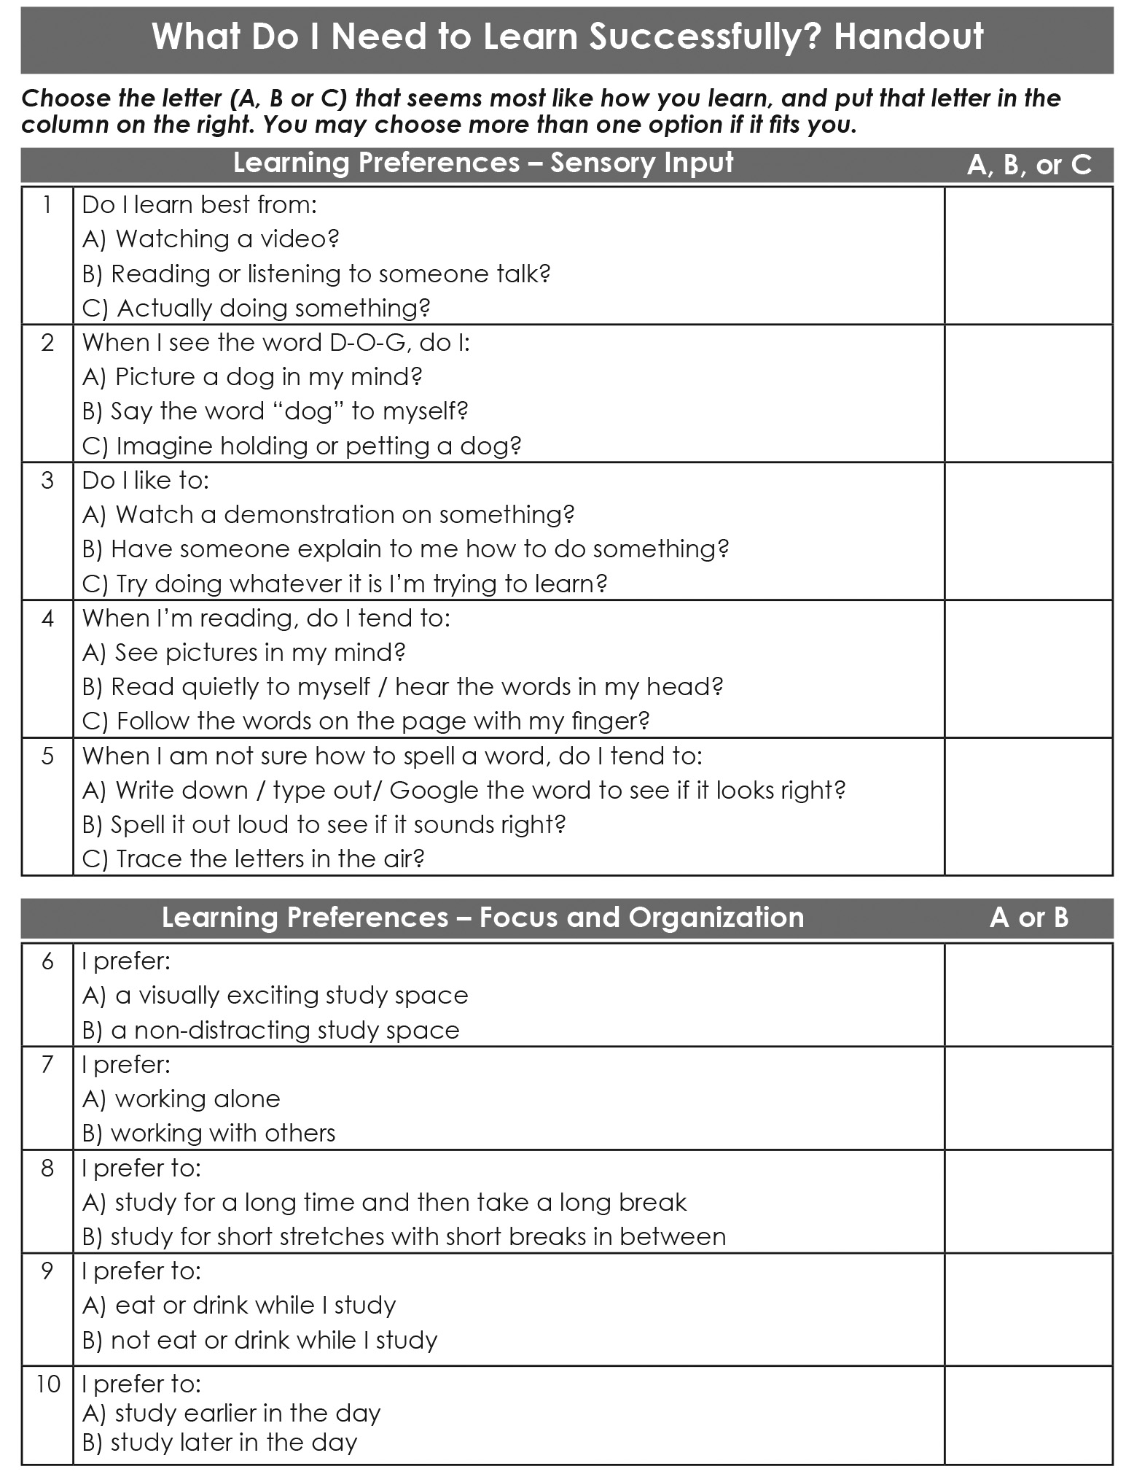

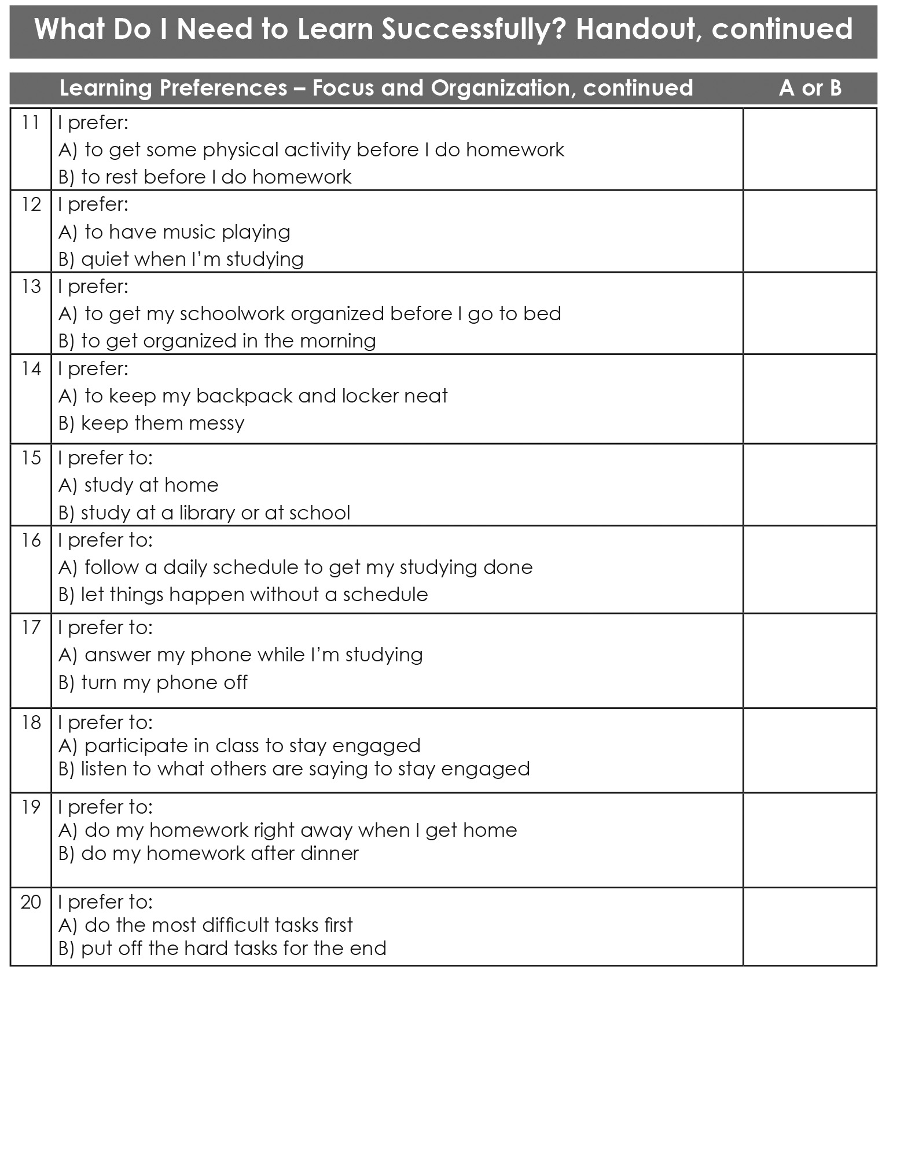

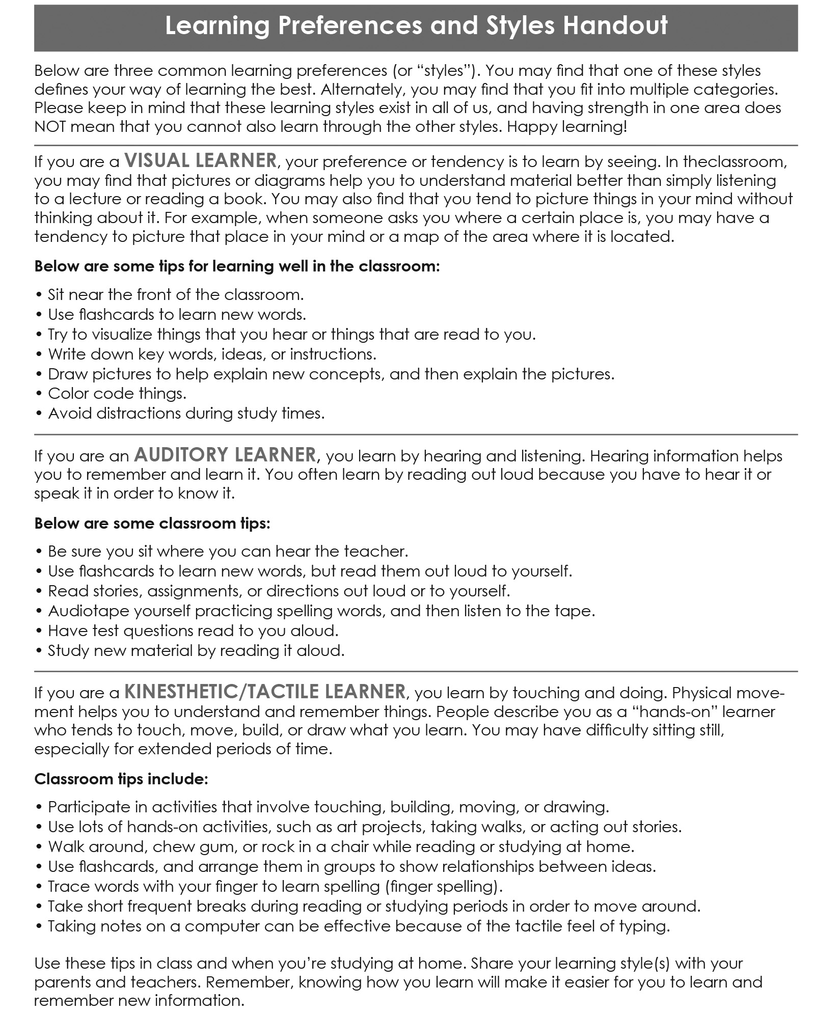

**Learning Strategies Reflection Questions**

1. Were you surprised by how many different ways you thought about how you could learn the information? Why or why not? ________________________________________________________________________________________________________________________________________________________________________________________________________________________________________________________________________________________________________________________________________________________________________________________

1. Now ask a family member, friend. or neighbor about something new they’ve had to learn. What was it? How did they go about learning it? List some responses here: __________________________________________________________________________________________________________________________________________________________________________________________________________________________________________________________________________________________________________________________________________________________________________________________________________________________________________________________________________________________________________________________________________________________________________________________________________________________________________________________________________________

____________________________________________________________________________________________________________________________________________________________________________________________

1. Which learning strategies or learning preferences from your family, neighbors, or friends were new ideas for you? __________________________________________________________________________________________________________________________________________________________________________________________________________________________________________________________________________________________
2. How can your teachers find out about your learning preferences? ____________________________________________________________________________________________________________________________________________________________________________________________
3. How can you let your family know what you need as a learner? ____________________________________________________________________________________________________________________________________________________________________________________________

**Thank you for completing this activity!**

See the top of the front page of this activity for instructions on how to submit it.