Social Media Posts |Note: These posts may also be shared via CPE and GUK social media platforms.
* Please use #GOvemberKY on all GO!vember-related posts. *

DAY | TOPIC | AUDIENCE | TEXT | IMAGE
MONDAY
 | Why to go to college | Students | $$$ The proof is in the paycheck: The more you learn, the more you earn! The first step toward earning more is graduating high school – and then getting more education after that. Whether you choose to go the short-term certificate route or the 2- or 4-year college route, it will pay off! $$$ #GOvemberKY | 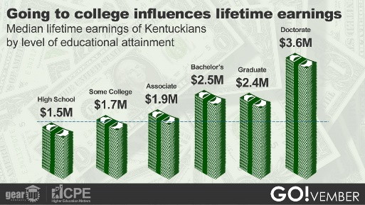  Mon_Why_Earnings
 |  | Family | Want your student to make good $$$ after high school? The proof is in the paycheck: The more they learn, the more they can earn! Whether they choose to go the short-term certification or the 2- or 4-year college route, it will pay off for them! #GOvemberKY | 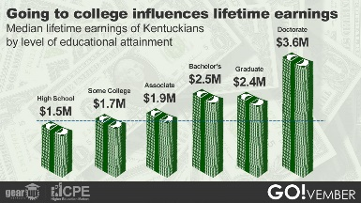  Mon_Why_Earnings
 |  | General | The proof is in the paycheck: The more you learn, the more you earn! Whether someone chooses to earn a short-term certification or goes on to earn a 2-year or 4-year degree (or beyond), it will pay off! #GOvemberKY | 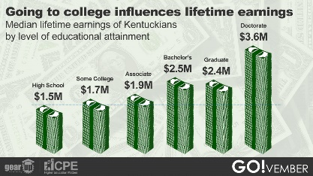  Mon_Why_Earnings
 | How to go to college | Students | Hey, HS seniors! NOW is the time to be filling out and submitting college applications. This video from KHEAA is a great place to start as you begin this exciting process! #GOvemberKY https://tinyurl.com/xkx72s4w
 |  |  | Not a high school senior yet? You should still be thinking about and planning for college! A great place to get started is by checking out the #GO!vemberKY resource page, where we’ve compiled some super-helpful links and docs for you! http://cpe.ky.gov/students/ | 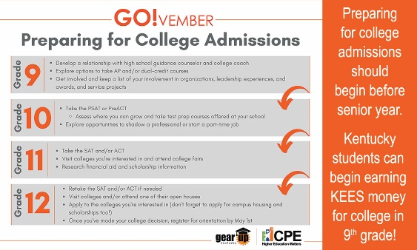Mon_How_Timeline
 |  | Family | Have a high school senior? NOW is the time for them to be filling out and submitting college applications. This video from KHEAA is a great place to start as they begin this exciting process! #GOvemberKY https://tinyurl.com/xkx72s4w
 |  |  | Even if your student isn’t a high school senior yet, you should still be thinking about and planning for college! A great place to get started is by checking out the #GO!vemberKY resource page, where we’ve compiled some helpful links and docs for you! http://cpe.ky.gov/students/ | Mon_How_Timeline
 |  | General | Know a high school senior? NOW is the time for them to be filling out and submitting college applications. This video from KHEAA is a great place to start as they begin this exciting process! #GOvemberKY https://tinyurl.com/xkx72s4w
 |  |  | It’s never too early to plan for college! A great place to get started is by checking out the helpful #GO!vemberKY college-going resource page: http://cpe.ky.gov/students/ | Mon_How_Timeline
TUESDAY
 | Why to go to college | Students | Want to make sure you get a job? If you earn a credential after high school – whether it’s a certificate, a 2- or 4-year degree or beyond – you are highly likely to be employed within one year after earning that credential. #GOvemberKY | 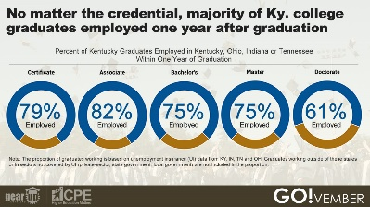  Tues_Why_Employment
 |  | Family | Want to ensure your student will have a job in the future? If they earn a credential after high school – whether it’s a certificate, a 2- or 4-year degree or beyond – they are highly likely to be employed within one year after earning that credential. #GOvemberKY | 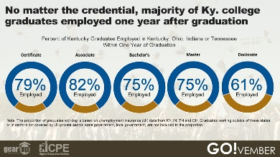  Tues_Why_Employment
 |  | General | Want a job? Earn a credential! When someone earns a credential after high school – whether it’s a certificate, a 2- or- 4-year degree or beyond – they are highly likely to be employed within one year after earning that credential. #GOvemberKY | 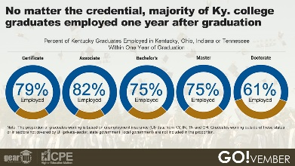  Tues_Why_Employment
 | How to go to college “early” | Students | Want to earn college credit while you’re in high school? Earning DUAL CREDIT has multiple benefits – from saving you time and $$$ to helping ensure you’ll have a better GPA your first year of college! #GOvemberKY | 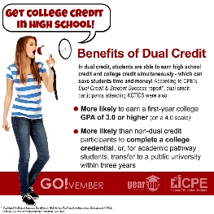  Tues_How_Dual_Credit  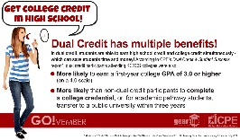Tues_How_Dual_Credit_16x9
 |  |  | Do you know about AP (Advanced Placement) courses? AP courses are designed to give you the experience of intro-level college courses while you are STILL IN HIGH SCHOOL. They are also a great way to save yourself time and $$$ because you may be able to earn college credit taking them! #GOvemberKY Find out more by clicking this link: https://tinyurl.com/9at7rky
 |  | Family | Did you know your student can earn college credit while they are in high school? Earning DUAL CREDIT has multiple benefits – from saving your student time and $$$ to helping ensure they’ll have a better GPA their first year of college! #GOvemberKY | Tues_How_Dual_Credit  Tues_How_Dual_Credit_16x9
 |  |  | Do you know about AP (Advanced Placement) courses? AP courses are designed to give students the experience of intro-level college courses while they are STILL IN HIGH SCHOOL! They are also a great way for students to save time and $$$ because they may be able to earn college credit taking them! #GOvemberKY Find out more by clicking this link: https://tinyurl.com/9at7rky
 |  | General | Did you know that students can earn college credit while they are in high school? Earning DUAL CREDIT has multiple benefits – from saving students time and $$$ to helping ensure they’ll have a better GPA their first year of college! #GOvemberKY | Tues_How_Dual_Credit  Tues_How_Dual_Credit_16x9
 |  |  | Did you know? Students taking an AP course have the opportunity to take an end-of-course exam and, based on their numerical score, may be awarded college credit for the course. #GOvemberKY Find out more: https://tinyurl.com/9at7rky
WEDNESDAY
 | Why to go to college | Students | Check this out: If you want to be able to get a job and keep a job that isn’t impacted by things like a pandemic, earning a credential after high school is the way to go! As you can see by this chart, the higher the level of education people have, the less likely they were to be unemployed during the height of the pandemic/shutdown. #GOvemberKY | 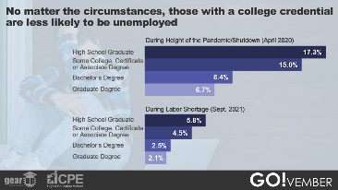  Wed_Why_Unemployment
 |  | Family | Want your student to be able to get and keep a job that isn’t impacted by things like a pandemic? Encourage them to earn a credential after high school! As you can see by this chart, the higher the level of education people have, the less likely they were to be unemployed during the height of the pandemic/shutdown. #GOvemberKY | 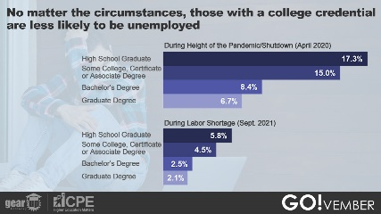  Wed_Why_Unemployment
 |  | General | During the height of the pandemic/shutdown, having a college credential significantly impacted whether a person was employed or not. As you can see by this chart, the higher the level of education people have, the less likely they were to be unemployed during the height of the pandemic/shutdown. #GOvemberKY | 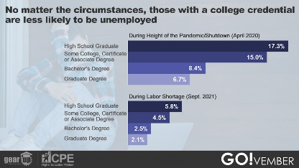  Wed_Why_Unemployment
 | How to go to college for less, pt. 1 | Students | Save $$$ - fill out that #FAFSA! At Kentucky’s public universities, students who filled out the FAFSA – in combination with merit aid – saved up to a third on college costs! #GOvemberKY | 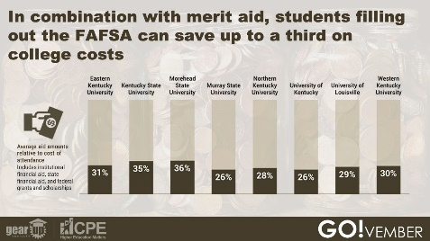  Wed_How_FAFSA
 |  |  | Don’t leave $$$ on the table – fill out the #FAFSA! #GOvember | 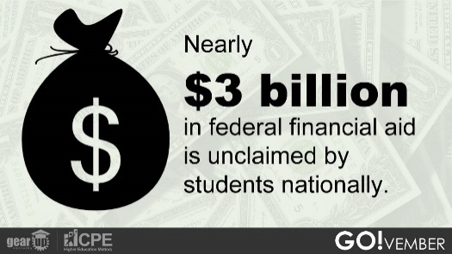  Wed_How_3Billion
 |  |  | ONE WEEK FROM TODAY! Students, if you’re planning to go to college, your parent/guardian should plan to attend “Paying for College 101,” a free, virtual event! To get more info and to register, go to: https://cpe.ky.gov/events/parentnight.html #GOvemberKY | 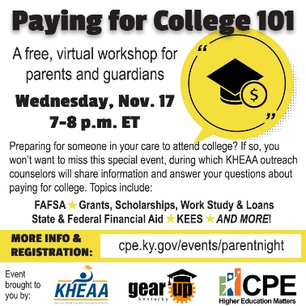  Virtual Parent Night_Square
 |  | Family | Trying to figure out how to pay for college? The first step is ensuring your student has filled out the #FAFSA! At Kentucky’s public universities, students who filled out the FAFSA – in combination with merit aid – saved up to a third on college costs! #GOvemberKY | 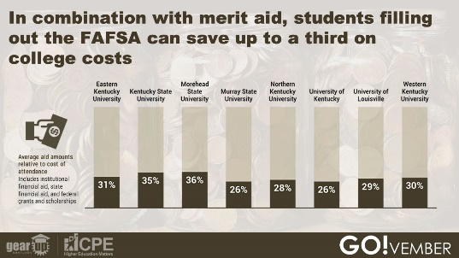  Wed_How_FAFSA
 |  |  | Don’t leave $$$ on the table – have your student fill out the #FAFSA! #GOvember | 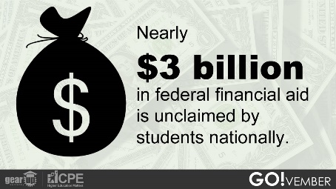  Wed_How_3Billion
 |  |  | ONE WEEK FROM TODAY! Do you have a student who is planning to attend college? If so, you’ll want to be sure to attend “Paying for College 101,” a free, virtual event! To get more info and to register, go to: https://cpe.ky.gov/events/parentnight.html #GOvemberKY | Virtual Parent Night_Square  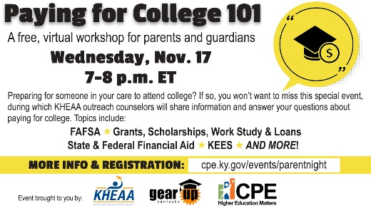  Virtual Parent Night_16x9
 |  | General | Filling out the #FAFSA pays off! At Kentucky’s public universities, students who filled out the FAFSA – in combination with merit aid – saved up to a third on college costs! #GOvemberKY | 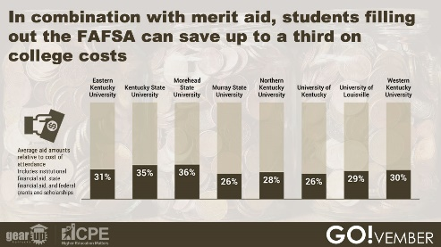  Wed_How_3Billion
 |  |  | Know someone who’s planning to go to college? Don’t let them leave $$$ on the table – encourage them to fill out the #FAFSA! #GOvember | 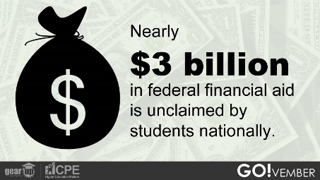  Wed_How_3Billion
 |  |  | ONE WEEK FROM TODAY! Do you know a student who is planning to attend college? If so, encourage their parents to attend “Paying for College 101,” a free, virtual event! To get more info and to register, go to: https://cpe.ky.gov/events/parentnight.html  #GOvemberKY | 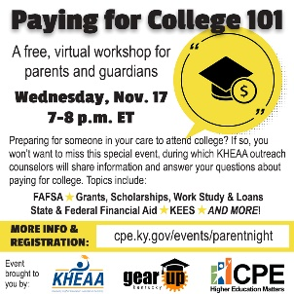  Virtual Parent Night_Square  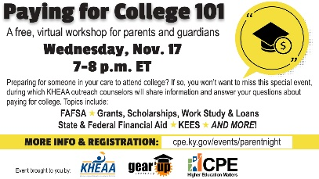  Virtual Parent Night_16x9
THURSDAY
 | Why to go to college | Students | Want to earn more $$$ more quickly? Work smarter, not harder! If you go to college for 4 years (and earn a bachelor’s degree), you can earn more than a high school grad with 8 years of work experience. #GOvemberKY | 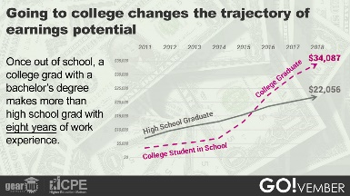  Thurs_Why_Trajectory
 |  | Family | If your student earns a college degree, they can earn more money more quickly! If they go to college for 4 years (and earn a bachelor’s degree), they can earn more than a high school grad with 8 years of work experience. #GOvemberKY | 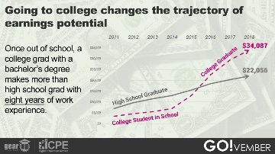  Thurs_Why_Trajectory
 |  | General | Work smarter, not harder! Someone who goes to college for 4 years (and earns a bachelor’s degree) can earn more than a high school grad with 8 years of work experience. #GOvemberKY | 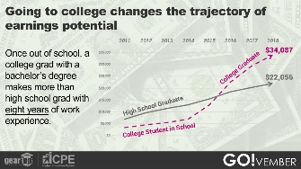  Thurs_Why_Trajectory
 | How to go to college for less, pt. 2 | Students | $$$ Could YOU qualify for a Pell grant to help pay for college? The first step to finding out is filling out a #FAFSA! $$$ #GOvemberKY | 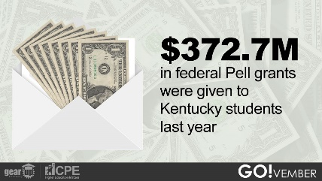  Thurs_How_Pell_2
 |  |  | Think you can’t afford college? Think again! There are at least four different ways you can pay for college – which you will find out about in this video from KHEAA! #GOvemberKY https://tinyurl.com/c4kxcny8
 |  | Family | Could your student qualify for a Pell grant to help pay for college? The first step to finding out is filling out a #FAFSA! #GOvemberKY | 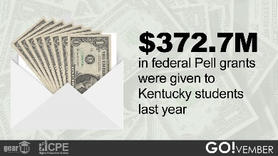  Thurs_How_Pell_2
 |  |  | Think your student can’t afford college? Think again! There are at least four different ways you can pay for college – which you will find out about in this video from KHEAA! #GOvemberKY https://tinyurl.com/c4kxcny8
 |  | General | Did you know that 2/5 of Kentucky’s public college/university undergrads receive Pell grants? The first step to getting a Pell grant? Filling out a #FAFSA! #GOvemberKY | 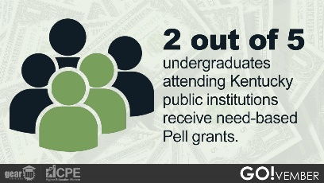  Thurs_How_Pell
 |  |  | Remember: The first step toward being awarded a Pell grant is completing a #FAFSA! #GOvemberKY | 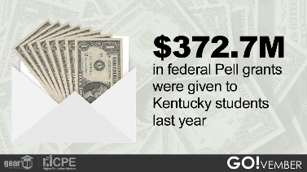  Thurs_How_Pell_2
 |  |  | College is worth it – and there are at least four different ways you can make it affordable! affordable! Find out more about ways to pay in this video from KHEAA! #GOvemberKY https://tinyurl.com/c4kxcny8
FRIDAY
 | Why to go to college | Students
 |  | Family
 |  | General
 | How to choose where to go – and what to study | Students | As you begin to figure out what you want to do as a career – and what you need to study to do that – be sure to check out the great info and tools on the GO!vember resource page! #GOvemberKY http://cpe.ky.gov/students/ | 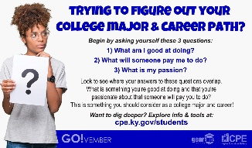  Fri_How_Where_16x9  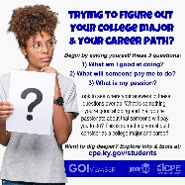  Fri_How_Where_Square
 |  | Family | As you help you student figure out their career path – and what they need to study to do that – be sure to check out the great info and tools on the GO!vember resource page! #GOvemberKY http://cpe.ky.gov/students/ | 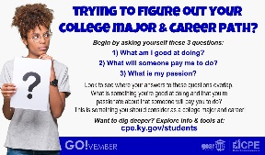  Fri_How_Where_16x9  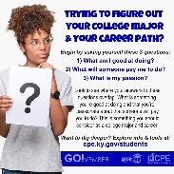  Fri_How_Where_Square
 |  |  | NEXT WEDNESDAY! Do you have a student who is planning to attend college? If so, you’ll want to be sure to attend “Paying for College 101,” a free, virtual event! To get more info and to register, go to: https://cpe.ky.gov/events/parentnight.html #GOvemberKY | 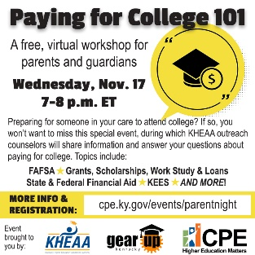  Virtual Parent Night_Square  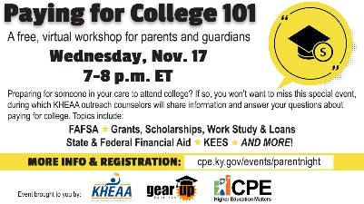  Virtual Parent Night_16x9
 |  | General | If you know a student who is figuring out their career path – and what they need to study to do that – encourage them to start by visiting the GO!vember resource page! #GOvemberKY http://cpe.ky.gov/students/ | 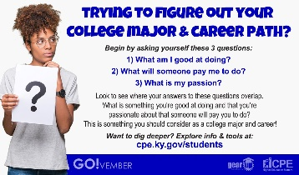  Fri_How_Where_16x9  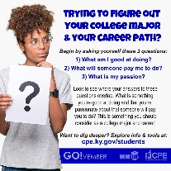  Fri_How_Where_Square
 |  | General | NEXT WEDNESDAY! Know a student who is planning to go to college? If so, encourage their parents to attend “Paying for College 101,” a free, virtual event! To get more info and to register, go to: https://cpe.ky.gov/events/parentnight.html  #GOvemberKY | 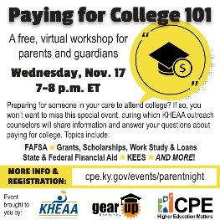  Virtual Parent Night_Square  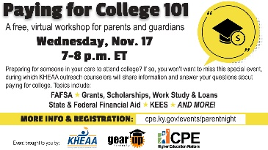  Virtual Parent Night_16x9

