General Guidelines:
- You can change colors for any visual element included in the templates below. To do so, click on the object you wish to update and select the color you’d like to update from the colored circles in the header menu. Then, from the color side bar, hit the “+” icon to add your brand’s color(s).
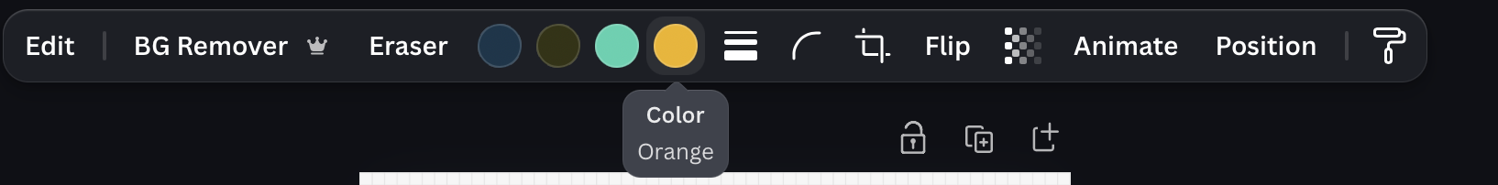
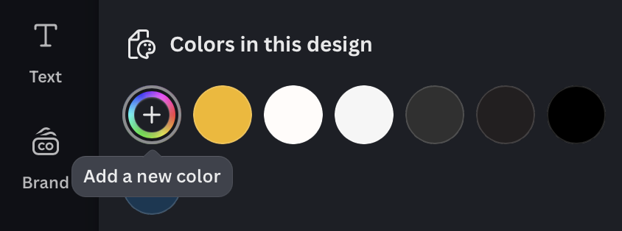

- Similarly, you can also change the font from Lato to your brand font(s). To do so, click on a text block and ensure that you highlight the entirety of the text inside. Then, update fonts, size, colors, and formatting in the text menu header that shows up above once you select text.
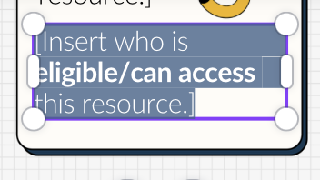

- Please note that the QR codes included in the templates below link to The Hope Center for Student Basic Needs or KYSSC’s website by default. Ensure that you update those to the link(s) for your basic needs website, contact form, resource information page, or other places you are directing students to. To do so, click and select the QR code. Then, update the “URL” field in the QR code sidebar:
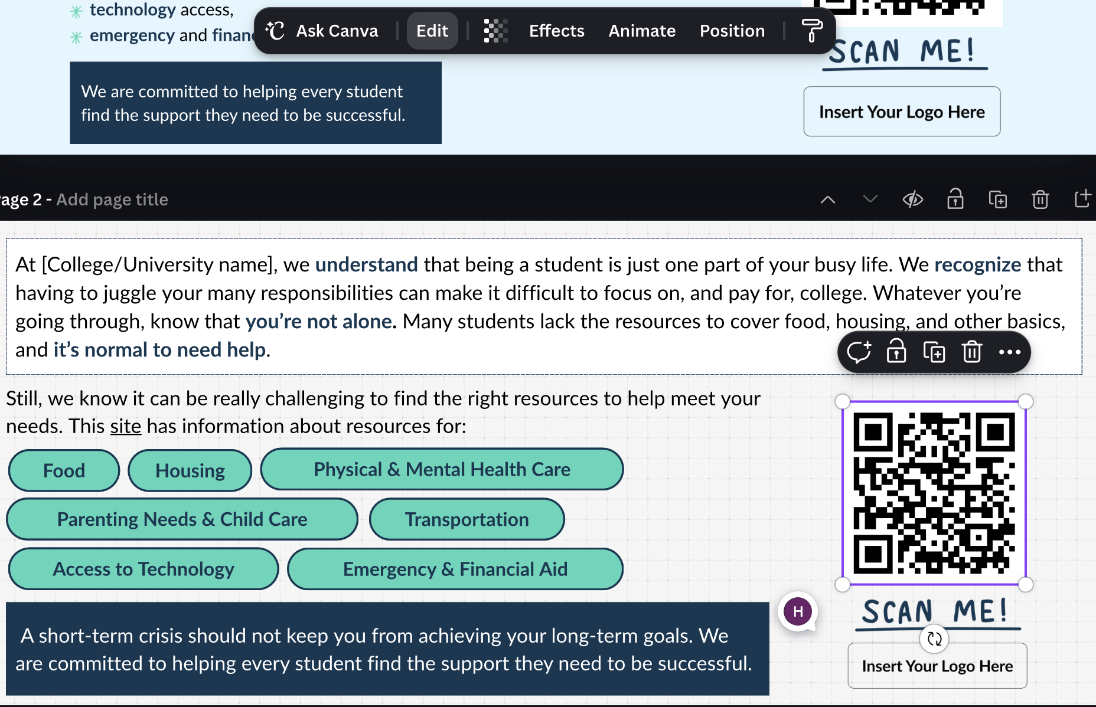
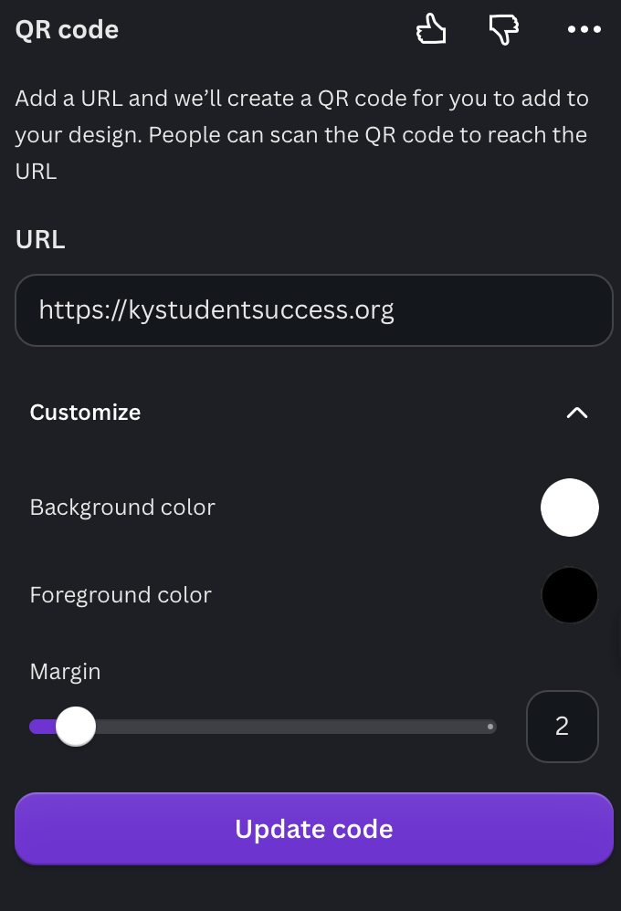

- Some templates also include a space with a placeholder image for you to insert your logo or visual mark. To do so, simply delete the placeholder image by selecting it and hitting backspace on your keyboard or clicking the trash bin icon.
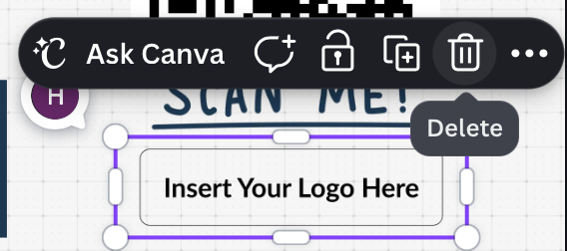
- For your convenience, we also created a Canva document with some miscellaneous icons you can use to copy and paste into your designs if you wish to play around with them.
- Lastly, please read the instructions below carefully to ensure that you’re downloading the correct file type and page, and resizing it appropriately depending on your needs. In addition, please head over to the “Templates” page under the “Toolkit Assets and Usage Guidelines” section on page 31 of the toolkit guide PDF for further instructions.

Direct Links to Templates:

Template for student testimonials:
- Please refer to the “Testimonial Production Guide” for best practices on ethically sourcing and publicizing student testimonials.

- To resize for different social media applications and other use cases, click resize from the menu in the top left corner:

- Pages 2-4 include some additional elements for you to play around with and plug into your design. On pages 2 and 3, we have included additional options for text boxes for quotes with different dimensions to offer you flexibility. On page 4, we’ve included other options for you to use for quotation marks.
- To download, click on “share” in the top right, and then press “download” from the dropdown:

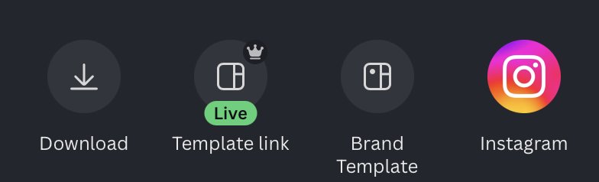

- In the download options, ensure that you select “current page” to only export one page at a time and avoid downloading pages 2-4 as those only contain additional, optional graphics.
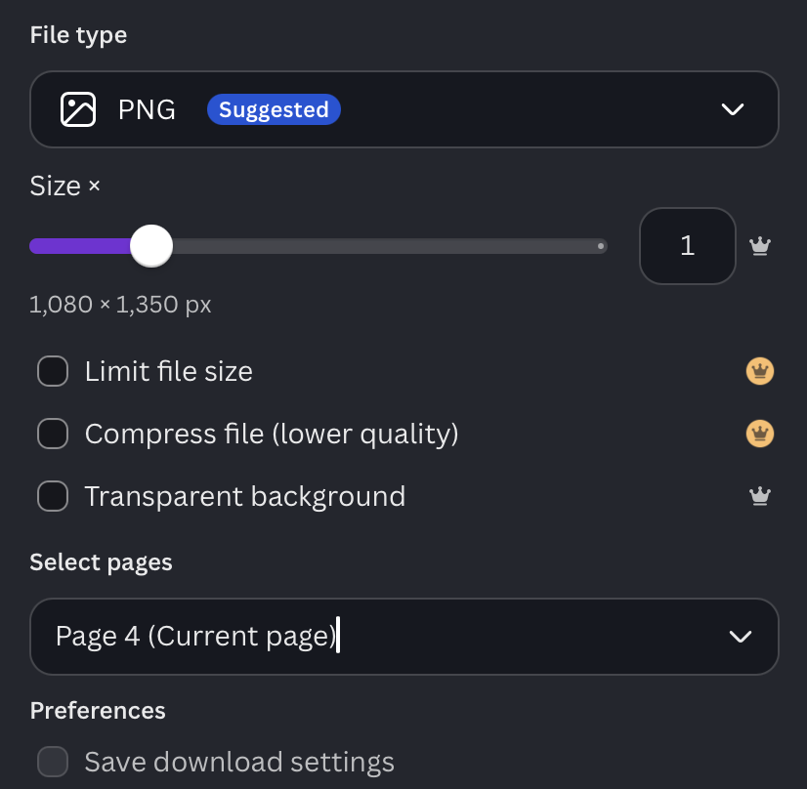

Template for Flyer 1 (Help-Seeking Encouragement):
- This flyer is optimized for print usage. However, feel free to use the graphic elements and suggested language for other use cases or resize it following the instructions above.
- To download for printing, click on “share” in the top right, and then press “download” from the dropdown:

- In the download options, ensure that you select “PDF Print” in the “File Type” dropdown to export a high resolution copy optimized for printing purposes:
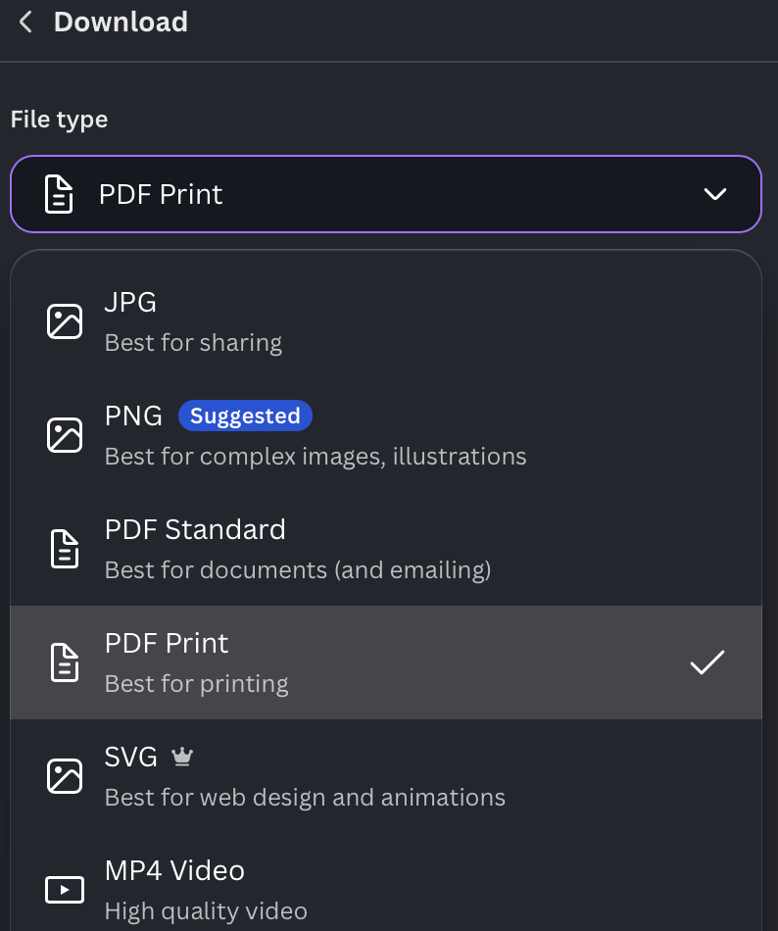

- If you wish to export for social media and other digital spaces, please select “PNG” in the “File Type” dropdown.

Template for Flyer 2 (Action-Oriented Resource Flyer Publicizing Support Services):
- This flyer is optimized for print usage. However, feel free to use the graphic elements and suggested language for other use cases or resize it following the instructions above.
- To download for printing, click on “share” in the top right, and then press “download” from the dropdown:

- In the download options, ensure that you select “PDF Print” in the “File Type” dropdown to export a high resolution copy optimized for printing purposes:

- If you wish to export for social media and other digital spaces, please select “PNG” in the “File Type” dropdown.

Template for Resource Slide Deck:
- This flyer’s dimensions are optimized for embedding within slide decks. We have included two different format options: page 1 is simpler for easy editing and page 2 includes additional stylization features for you to play around with if you have capacity.
- To download to use within a slide deck, click on “share” in the top right, and then press “download” from the dropdown:

- In the download options, ensure that you select “current page” to only export one page at a time.

- To embed within an existing slide deck, click on “Insert” and select “image” in the top header menu. From the resulting dropdown options, select “upload from computer.”
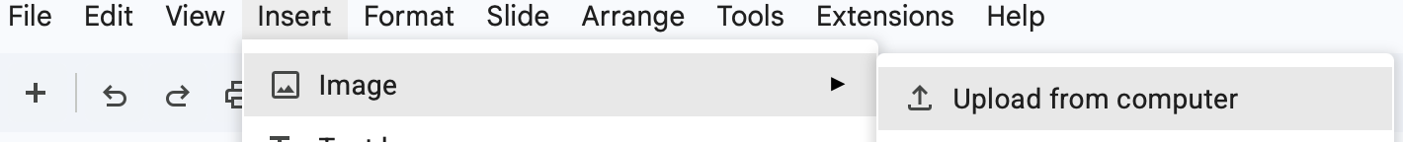

- Once inserted, increase or decrease image size to fit it within the slide frame, if needed.

